Smart Ticketing System
Ticket Vendor Machine (TVM)
Software Engineering Lab Group Assignment 1 – Sem 1_2627
Group [XX]
1. 524K0040 : Pham Le Duc Tri
2. 524K0038 : Truong Minh Quang
3. 524K0025 : Pham Minh Tai
4. 524K0024 : Vu Hoang Phuc
5. 524K0022 : Nguyen Ngoc Nhat Minh

GitHub repository | Figma / other link | Date submitted
[link] | [link] | [30/10/2026]

Table of Contents
Table of Contents 2
1. Introduction 4
1.1 Purpose and Scope 4
1.2 Problem Statement in Our Own Words 4
1.3 Team and Roles 4
2. Phase 1: Requirements Engineering (20 marks) 5
2.1 Clarification Q&A (5 marks) 5
2.2 Requirements Specification (15 marks) 6
2.2.1 Functional Requirements 6
2.2.2 Non-Functional Requirements 7
2.2.3 Domain Requirements 8
3. Phase 2: UML Modeling & System Design (35 marks) 9
3.1 Use Case Modeling (10 marks) 9
3.1.1 Use Case Diagram 9
3.1.2 Actors and Use Case List 9
3.1.3 Use Case Descriptions 10
3.2 Activity Diagrams (10 marks) 16
3.2.1 Passenger Buys a Ticket at the TVM 16
3.2.2 Communication with External Payment Gateways 17
3.3 Detailed System Modeling: Main Use Case "Buy a Ticket" (15 marks) 18
3.3.1 Sequence Diagram 18
3.3.2 State Chart Diagram 19
3.3.3 Class Diagram (Domain Model) 21
3.4 Model Consistency Check 23
4. Phase 3: UI/UX & Architecture (15 marks) 24
4.1 UI/UX Design (5 marks) 24
4.2 Architectural Design (10 marks) 32
4.2.1 Architecture Diagram 32
4.2.2 Deployment Diagram 33
5. Phase 4: Implementation, Tooling & Demo (30 marks) 35
5.1 Visual Studio Engineering: Model-to-Code (10 marks) 35
5.1.1 Forward Engineering (Model to Code) 35
5.1.2 Backward Engineering (Code to Model) 37
5.1.3 Code Map 40
5.2 GitHub & AI Tooling (10 marks) 40
5.2.1 Source Control 40
5.2.2 AI Assistance: Copilot Prompt Documentation 41
5.2.3 Reflection on AI Use 42
5.3 Demo Application (10 marks) 42
6. Checklist for "LabGroup_QT2_Assignment1.pdf" 43
7. Contribution of Each Member 44
8. Conclusion and Lessons Learnt 44
Appendix 46
Appendix A: readme.txt 46
Appendix B: Full-size Diagrams 46

1. Introduction

1.1 Purpose and Scope
This report describes the design and a working demo of the Ticket Vendor Machine (TVM), which is part of the Smart Ticketing System. It covers four phases: requirements, UML models and system design, screen and architecture design, and the Visual Studio, GitHub and C#/MSSQL demo work for the “Buy a Ticket” flow. Payment in the demo is simulated. The bank and wallet apps, real payment providers, and the system that checks tickets later are outside our scope.

1.2 Problem Statement in Our Own Words
The Ticket Vendor Machine (TVM) is a machine that sells Bus and MRT tickets, so passengers can buy one without a staff member. The passenger presses Start, sees a list of destinations, picks one, and sees the fare. Then they choose how to pay: a credit or debit card, a QR code linked to their bank, or a digital wallet. For a card, the machine asks the passenger to insert or tap it. For QR or wallet payment, the machine shows a QR code on its screen and the passenger scans it with their phone. Once the payment is confirmed, the machine prints a paper ticket with a barcode and goes back to the start screen.

The original description leaves many things unclear. It doesn’t say which tickets are sold, where the fares come from, or how the machine knows a payment really worked. It doesn’t say how long to wait for a payment, what happens if a card is declined or the passenger cancels, or what happens if the payment works but the printer fails or runs out of paper. It also doesn’t explain how refunds work or how fast and reliable the machine must be.

We answered these questions in our Q&A (Section 2.1) and turned the answers into clear requirements (Section 2.2). We cover the TVM and how it works with the payment providers and the fare data. The bank and wallet apps and the system that checks tickets later are outside our scope.

1.3 Team and Roles
No. | Name | Student ID | Main responsibilities
1 | Pham Le Duc Tri | 524K0040 | Phase 4
2 | Truong Minh Quang | 524K0038 | Phase 3
3 | Pham Minh Tai | 524K0025 | Phase 1
4 | Vu Hoang Phuc | 524K0024 | Phase 2
5 | Nguyen Ngoc Nhat Minh | 524K0022 | Phase 4

2. Phase 1: Requirements Engineering (20 marks)

2.1 Clarification Q&A (5 marks)
ID | Question to the stakeholder | Assumed answer | Why it matters | Requirement ID
01 | Which transport services and ticket types will the TVM support? | Initially, Bus and MRT tickets; one ticket per transaction. | Defines the initial scope and prevents unsupported ticket types from being assumed. | FR2, FR3, DR1
Q02 | How does a passenger select a destination? | Passenger presses Start, chooses a transport service and destination, then confirms the selection. | Defines the main user flow and interface screens. | FR1, FR2, FR3
Q03 | How is the fare determined? | The TVM retrieves the current fare from the authorized transport operator based on service and destination. | Incorrect fare calculation could lead to incorrect charges or invalid tickets. | FR4, DR1, DR2
Q04 | Which payment methods are supported? | Credit/debit card where supported, banking-linked QR payment, and approved digital wallets. | Each method requires a different payment interaction and integration. | FR5, FR6, FR7, DR3
Q05 | How do QR payment and digital-wallet payment work? | The TVM displays a transaction-specific QR code; the passenger scans it using a compatible banking or wallet app. | Clarifies which device displays the QR code and how the payment begins. | FR7, DR3
Q06 | How does the TVM verify that payment succeeded? | A trusted payment provider response is verified by the TVM; a passenger's phone screen alone is not sufficient. | Prevents issuing tickets based on unverified payment claims. | FR8, NFR3, DR4
Q07 | How long should the TVM wait for payment confirmation? | Wait up to 60 seconds for initial confirmation, then show a pending/timeout message and reconcile the transaction status before retrying. | Prevents indefinite waiting and accidental duplicate charges. | FR9, FR13, NFR4
Q08 | What happens if a payment is declined or fails? | Display a clear failure message and let the passenger retry or cancel; do not issue a paid ticket. | Defines a safe failure path. | FR9, FR13
Q09 | What information must the ticket contain? | A unique ticket identifier, barcode, transport/ticket details, fare or ticket type, and required validity information. | Supports ticket validation and transport-operator rules. | FR10, FR11, DR5
Q10 | What happens if payment succeeds but the printer fails or runs out of paper? | Record the payment and print failure, prevent a second charge for the same purchase, and follow a defined recovery/refund process. | Payment and ticket delivery can fail independently. | FR12, FR14, NFR2

2.2 Requirements Specification (15 marks)

2.2.1 Functional Requirements
ID | Requirement ("The system shall…") | Priority | Use case | Source (Q&A)
FR1 | The system shall display an idle/start screen when the TVM is ready for a new passenger. | Must | UC01 | Q02
FR2 | When the passenger presses Start, the system shall display the supported transport services and destinations. | Must | UC01 | Q01, Q02
FR3 | The system shall allow the passenger to select and confirm a destination. | Must | UC01 | Q02
FR4 | The system shall retrieve and display the fare for the selected transport service and destination before payment. | Must | UC01 | Q03
FR5 | The system shall allow the passenger to choose a supported payment method: card, banking-linked QR, or digital wallet. | Must | UC02 | Q04
FR6 | For card payment, the system shall initiate a transaction through the approved card terminal/payment gateway. | Must | UC02 | Q04
FR7 | For QR or digital-wallet payment, the system shall generate and display a unique QR code linked to the current transaction. | Must | UC02 | Q05
FR8 | The system shall verify payment using an authenticated response from the trusted payment provider before issuing a paid ticket. | Must | UC02, UC03 | Q06, Q13
FR9 | The system shall display the payment status as successful, failed, pending, or timed out, as applicable. | Must | UC02 | Q07, Q08
FR10 | After verified payment, the system shall generate a unique ticket identifier and corresponding barcode. | Must | UC03 | Q09
FR11 | The system shall print the ticket with the barcode and required ticket information. | Must | UC03 | Q09
FR12 | The system shall record the transaction identifier, fare, payment status, ticket status, and timestamp. | Must | UC03, UC04 | Q10, Q18
FR13 | If payment fails, the system shall not issue a paid ticket and shall allow the passenger to retry or cancel. | Must | UC02 | Q07, Q08
FR14 | If payment succeeds but printing fails, the system shall record the failure and support recovery/refund without charging again for the same purchase. | Must | UC04 | Q10
FR15 | The system shall allow the passenger to cancel before payment completion and shall check transaction status if payment may already have been submitted. | Must | UC01, UC02 | Q11
FR16 | After a completed or cancelled transaction, the system shall return to the idle/start screen. | Must | UC04 | Q12
FR17 | The system shall expire a pre-payment session after 60 seconds of inactivity and clear temporary session data. | Should | UC01 | Q12
FR18 | The system shall prevent duplicate ticket issuance for the same successfully paid transaction. | Must | UC03, UC04 | Q07, Q10, Q11
FR19 | If a required service is unavailable, the system shall display a service-unavailable message and prevent unsafe ticket issuance. | Must | UC04 | Q13
FR20 | The system shall provide multiple languages interface options. | Should | UC01 | Q15

2.2.2 Non-Functional Requirements
ID | Category | Measurable requirement | Measurement method | Related FR
NFR1 | Reliability / Availability | The TVM shall achieve at least 99.5% operational availability per calendar month, excluding approved scheduled maintenance. | Measure scheduled service time and unplanned downtime monthly. Availability = (scheduled service time − unplanned downtime) / scheduled service time × 100%. | FR1–FR19
NFR2 | Reliability / Recovery | For recoverable software or communication incidents, the TVM shall restore service within 5 minutes in at least 95% of incidents, provided hardware and external services are available. | Test at least 100 simulated recoverable incidents; record incident-to-service-restored time. | FR12, FR14, FR19
NFR3 | Reliability / Transaction integrity | The TVM shall issue no paid ticket without verified payment and shall prevent duplicate charging or ticket issuance for the same transaction. | Run tests with declined, duplicated, delayed, and repeated payment notifications; verify transaction and ticket records. | FR8, FR10, FR12, FR18
NFR4 | Response time | The TVM shall display the destination menu within 2 seconds after Start in at least 95% of requests when destination data is available and the system is under the agreed normal test load. | Measure 1,000 Start-to-menu-display requests; at least 950 must be ≤2 seconds. | FR2
NFR5 | Response time | Local user actions (for example, selecting a destination or payment method) shall receive a visible response within 1 second in at least 95% of requests under the agreed normal test load. | Measure 1,000 local interaction events; at least 950 must be ≤1 second. | FR3, FR5
NFR6 | Response time / Timeout | The TVM shall wait no longer than 60 seconds for initial payment confirmation before showing a pending/timeout message, and shall reconcile transaction status before permitting a retry that could create another charge. | Run payment simulations with success, failure, delayed response, and no response; verify timeout and reconciliation logs. | FR7–FR9, FR13, FR18
NFR7 | Security | The TVM shall use encrypted communication with payment services and shall not store full card numbers or card verification codes in local logs. | Inspect configuration, network traffic, and logs during security testing. | FR6–FR8, FR12
NFR8 | Usability | The TVM shall provide Vietnamese and English instructions and clear error messages for payment failure, timeout, and printer failure. | Verify all required screens in both languages and test each listed error scenario. | FR9, FR13, FR14, FR20
NFR9 | Maintainability / Logging | The TVM shall record timestamped diagnostic events for payment failures, printer failures, service outages, and recovery actions without logging sensitive card data. | Trigger each failure scenario and inspect the resulting logs. | FR12, FR14, FR19

2.2.3 Domain Requirements
ID | Domain requirement | Domain / source | Related FR / NFR
DR1 | Ticket fares shall follow the current fare rules published by the authorized transport operator. | Transport operator fare policy | FR4
DR2 | The TVM shall use the authorized transport operator's destination list and fare data. | Transport operator data source | FR2, FR4
DR3 | QR and wallet transactions shall follow the selected provider's QR format, transaction-expiry rules, and confirmation protocol. | Bank / QR / digital-wallet provider | FR5, FR7–FR9
DR4 | A ticket shall be treated as paid and eligible for use only after successful payment has been verified. | Transport and payment business rules | FR8, FR10, FR11
DR5 | Each issued ticket shall have a unique identifier and barcode readable by the designated ticket-validation system, and shall include required ticket/validity details. | Transport operator ticketing specification | FR10, FR11
DR6 | Card transactions shall follow applicable payment-provider requirements and payment-card security standards, including PCI DSS where applicable. | Payment provider / applicable card-security standards | FR6, NFR7
DR7 | Transaction and operational records shall be retained for the period required by applicable Vietnamese law and the transport operator's policies. | Applicable Vietnamese law / operator policy | FR12, NFR9
DR8 | Refunds and payment reversals shall follow the applicable transport operator and payment-provider procedures. | Transport operator / payment provider | FR14, FR15
DR9 | The TVM shall comply with applicable Vietnamese requirements concerning electronic payments, personal data protection, and public transportation ticketing. | Applicable Vietnamese laws and regulations | FR6–FR12, NFR7

3. Phase 2: UML Modeling & System Design (35 marks)

3.1 Use Case Modeling (10 marks)

3.1.1 Use Case Diagram
[ Use case diagram ] 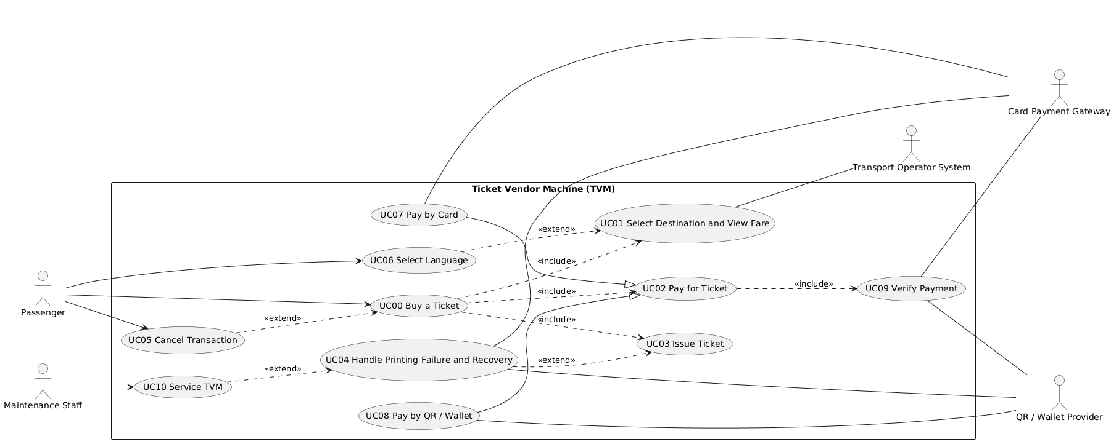

3.1.2 Actors and Use Case List
ID | Use case | Primary actor | Short description
UC00 | Buy a Ticket | Passenger | Passenger selects a destination, pays, and receives a printed ticket.
UC01 | Select Destination and View Fare | Passenger | Passenger chooses a service and destination and confirms the fare shown.
UC02 | Pay for Ticket | Passenger | Passenger chooses a payment method and the TVM tracks the payment result.
UC03 | Issue Ticket | Passenger | After verified payment, the TVM generates the ticket ID and barcode and prints the ticket.
UC04 | Handle Printing Failure and Recovery | Passenger | If printing fails after payment, the TVM logs it, avoids a second charge, and starts a refund or recovery.
UC05 | Cancel Transaction | Passenger | Passenger cancels, or the 60 s idle limit expires, and the session is cleared.
UC06 | Select Language | Passenger | Passenger switches the interface between Vietnamese and English.
UC07 | Pay by Card | Passenger | Passenger inserts or taps a card and the TVM sends the authorization to the card gateway.
UC08 | Pay by QR / Wallet | Passenger | TVM shows a transaction QR code and the passenger confirms payment in a banking or wallet app.
UC09 | Verify Payment | Payment Gateway / QR Wallet Provider | TVM checks the signed confirmation, transaction ID, amount and duplicates before marking payment verified.
UC10 | Service TVM | Maintenance Staff | Staff clear a fault, refill paper, run a health check, and return the TVM to service.

3.1.3 Use Case Descriptions
UC00: Buy a Ticket
Item | Content
Use case ID and name | UC00 Buy a Ticket
Primary actor / secondary actors | Passenger / Transport Operator System, Payment Gateway, QR / Wallet Provider
Related requirements | FR1 to FR19; NFR1, NFR3, NFR4, NFR5, NFR6; DR1 to DR5
Pre-conditions | TVM is in service and showing the idle screen.
Trigger | Passenger presses Start.
Main flow | 1. Passenger presses Start.  2. TVM displays destinations.  3. Passenger selects a destination.  4. TVM retrieves and displays the fare (UC01).  5. Passenger confirms the destination.  6. Passenger selects a payment method.  7. TVM creates the transaction and prompts for card or QR (UC02, UC07/UC08).  8. Payment Gateway processes the payment.  9. TVM receives and verifies the result (UC09).  10. TVM generates the ticket ID and barcode and prints the ticket (UC03).  11. TVM dispenses the ticket, marks the transaction COMPLETED, and returns to idle.
Alternate flows | 5a. Passenger cancels or is idle for 60 s: UC05.  6a. Passenger changes language: UC06.
Exception flows | 4a. Fare data unavailable: TVM shows “Service unavailable” and returns to idle.  9a. Payment failed or timed out: see UC02.  10a. Printer error or paper out: see UC04
Post-conditions | A ticket is printed and the transaction is COMPLETED, or the transaction is CANCELLED or FAILED with no paid ticket left without a refund process.

UC01: Select Destination and View Fare
Item | Content
Use case ID and name | UC01 Select Destination and View Fare
Primary actor / secondary actors | Passenger / Transport Operator System
Related requirements | FR1 to FR4, FR17, FR19, FR20; NFR4, NFR5; DR1, DR2
Pre-conditions | TVM is idle and in service.
Trigger | Passenger presses Start.
Main flow | 1. Passenger presses Start.  2. TVM displays services and destinations within 2 s.  3. Passenger selects a destination.  4. TVM retrieves and displays the fare.  5. Passenger confirms the selection.
Alternate flows | 2a. Passenger changes language: UC06.  3a. Passenger changes the destination before confirming: return to step 2.
Exception flows | 4a. Fare data unavailable: TVM shows “Service unavailable” and returns to idle.  5a. Passenger idle for 60 s: session expires (UC05).
Post-conditions | A destination and fare are confirmed for the transaction.

UC02: Pay for Ticket
Item | Content
Use case ID and name | UC02 Pay for Ticket
Primary actor / secondary actors | Passenger / Payment Gateway, QR / Wallet Provider
Related requirements | FR5 to FR9, FR13, FR15, FR18; NFR3, NFR6; DR3, DR4, DR8
Pre-conditions | A fare is confirmed.
Trigger | Passenger confirms the destination and fare.
Main flow | 1. TVM displays the payment methods (Card, Banking QR, Wallet).  2. Passenger chooses a method.  3. TVM creates the transaction and a payment request.  4. Passenger pays (UC07 or UC08).  5. TVM verifies the result (UC09).  6. TVM displays the payment status as successful.
Alternate flows | 4a. Passenger cancels before paying: UC05.
Exception flows | 5a. Payment declined: TVM shows “Payment failed”; passenger retries or cancels.  5b. No response within 60 s: TVM shows “Pending”, reconciles the status, and allows a retry only if the status is confirmed failed.  5c. Verification fails: TVM rejects the result and keeps the payment unverified.
Post-conditions | Payment is VERIFIED, FAILED, or PENDING. No ticket is issued unless it is VERIFIED.
UC03: Issue Ticket
Item | Content
Use case ID and name | UC03 Issue Ticket
Primary actor / secondary actors | Passenger / none
Related requirements | FR10 to FR12, FR16, FR18; NFR3; DR4, DR5, DR7
Pre-conditions | Payment is VERIFIED.
Trigger | TVM marks the payment VERIFIED.
Main flow | 1. TVM generates a unique ticket ID and barcode.  2. TVM prints the ticket.  3. TVM records the transaction ID, fare, payment status, ticket status, and timestamp.  4. TVM dispenses the ticket and returns to idle.
Alternate flows | None
Exception flows | 2a. Printer error or paper out: UC04.
Post-conditions | One ticket is printed and recorded; no duplicate ticket exists for the transaction.

UC04: Handle Printing Failure and Recovery
Item | Content
Use case ID and name | UC04 Handle Printing Failure and Recovery
Primary actor / secondary actors | Passenger / Payment Gateway, QR / Wallet Provider
Related requirements | FR12, FR14, FR16, FR19; NFR2, NFR8, NFR9; DR8
Pre-conditions | Payment is VERIFIED and printing has failed.
Trigger | Printer reports an error or paper out.
Main flow
  1. TVM detects the printer error.
  2. TVM records PRINT_FAILED and logs the failure.
  3. TVM shows the error and a reference number.
  4. TVM starts the refund or recovery process.
  5. TVM returns to idle.
Alternate flows | 4a. Printer recovers: TVM reprints the same ticket without charging again.
Exception flows | 4b. Refund request fails: TVM flags the transaction for manual follow-up.  5a. Printer unusable: TVM goes out of service (UC10).
Post-conditions | The failure is logged, the passenger is not charged again for the same purchase, and a refund or reprint is started.

UC05: Cancel Transaction
Item | Content
Use case ID and name | UC05 Cancel Transaction
Primary actor / secondary actors | Passenger / none
Related requirements | FR15, FR16, FR17; NFR6; DR8
Pre-conditions | A transaction is in progress.
Trigger | Passenger presses Cancel, or 60 s of inactivity before payment.
Main flow | 1. Passenger presses Cancel.  2. TVM clears session data.  3. TVM records the transaction as CANCELLED.  4. TVM returns to idle.
Alternate flows | 1a. 60 s idle before payment: TVM expires the session and continues from step 2.
Exception flows | 1b. Payment may already be submitted: TVM checks the status first; if payment is confirmed, it continues to ticket issuance or refund.
Post-conditions | The transaction is CANCELLED and session data is cleared.

UC06: Select Language
Item | Content
Use case ID and name | UC06 Select Language
Primary actor / secondary actors | Passenger / none
Related requirements | FR20; NFR8
Pre-conditions | TVM is showing any passenger screen.
Trigger | Passenger presses the language button.
Main flow | 1. Passenger selects Vietnamese or English.  2. TVM redisplays all screens and messages in that language.
Alternate flows | None
Exception flows | None
Post-conditions | The interface uses the chosen language until the session ends.

UC07: Pay by Card
Item | Content
Use case ID and name | UC07 Pay by Card
Primary actor / secondary actors | Passenger / Card Payment Gateway
Related requirements | FR6; NFR7; DR6, DR9
Pre-conditions | Passenger chose Card as the payment method.
Trigger | TVM prompts for the card.
Main flow | 1. TVM prompts “Insert or tap card”.  2. Passenger inserts or taps the card.  3. TVM sends the authorization request to the gateway.  4. Gateway returns the result.
Alternate flows | 2a. Passenger cancels: UC05.
Exception flows | 2b. Card unreadable: TVM asks the passenger to try again or choose another method.  4a. Card declined: UC02 failure path.
Post-conditions | The gateway has returned an authorization result for the transaction. Full card numbers and CVV are not stored.

UC08: Pay by QR / Wallet
Item | Content
Use case ID and name | UC08 Pay by QR / Wallet
Primary actor / secondary actors | Passenger / QR / Wallet Provider
Related requirements | FR7, FR9; DR3
Pre-conditions | Passenger chose Banking QR or Wallet.
Trigger | TVM requests a payment from the provider.
Main flow | 1. TVM generates a unique QR code for the transaction.  2. TVM displays the QR code.  3. Passenger scans it with a banking or wallet app and confirms.  4. Provider sends the payment result.
Alternate flows | 3a. Passenger cancels: UC05.
Exception flows | 3b. QR expires or no confirmation within 60 s: UC02 timeout path.  4a. Payment declined by the bank or wallet: UC02 failure path.
Post-conditions | The provider has returned a payment result for the transaction.

UC09: Verify Payment
Item | Content
Use case ID and name | UC09 Verify Payment
Primary actor / secondary actors | Payment Gateway, QR / Wallet Provider / none
Related requirements | FR8, FR18; NFR3; DR3, DR4
Pre-conditions | A payment request has been sent to the provider.
Trigger | TVM receives a payment confirmation.
Main flow | 1. TVM receives the signed confirmation.  2. TVM verifies the signature.  3. TVM checks the transaction ID, amount, and currency.  4. TVM checks that it is not a duplicate notification.  5. TVM marks the payment VERIFIED.
Alternate flows | None
Exception flows | 2a. Signature invalid or data mismatch: TVM rejects the notification and keeps the payment unverified.  4a. Duplicate notification: TVM ignores it and issues no second ticket.
Post-conditions | The payment is VERIFIED, or it stays unverified and no ticket can be issued.

UC10: Service TVM
Item | Content
Use case ID and name | UC10 Service TVM
Primary actor / secondary actors | Maintenance Staff / none
Related requirements | FR19; NFR1, NFR2, NFR9
Pre-conditions | TVM is OUT_OF_SERVICE, or a printer failure has been logged.
Trigger | Staff attend the TVM after a fault.
Main flow | 1. Staff open the TVM and read the logged fault.  2. Staff refill paper or fix the fault.  3. Staff run a health check.  4. TVM logs the recovery action and returns to idle.
Alternate flows | None
Exception flows | 3a. Health check fails: TVM stays out of service and the fault stays logged.
Post-conditions | The fault is cleared, the recovery is logged, and the TVM is back in service.

3.2 Activity Diagrams (10 marks)

3.2.1 Passenger Buys a Ticket at the TVM
[ Activity diagram: buy a ticket ] 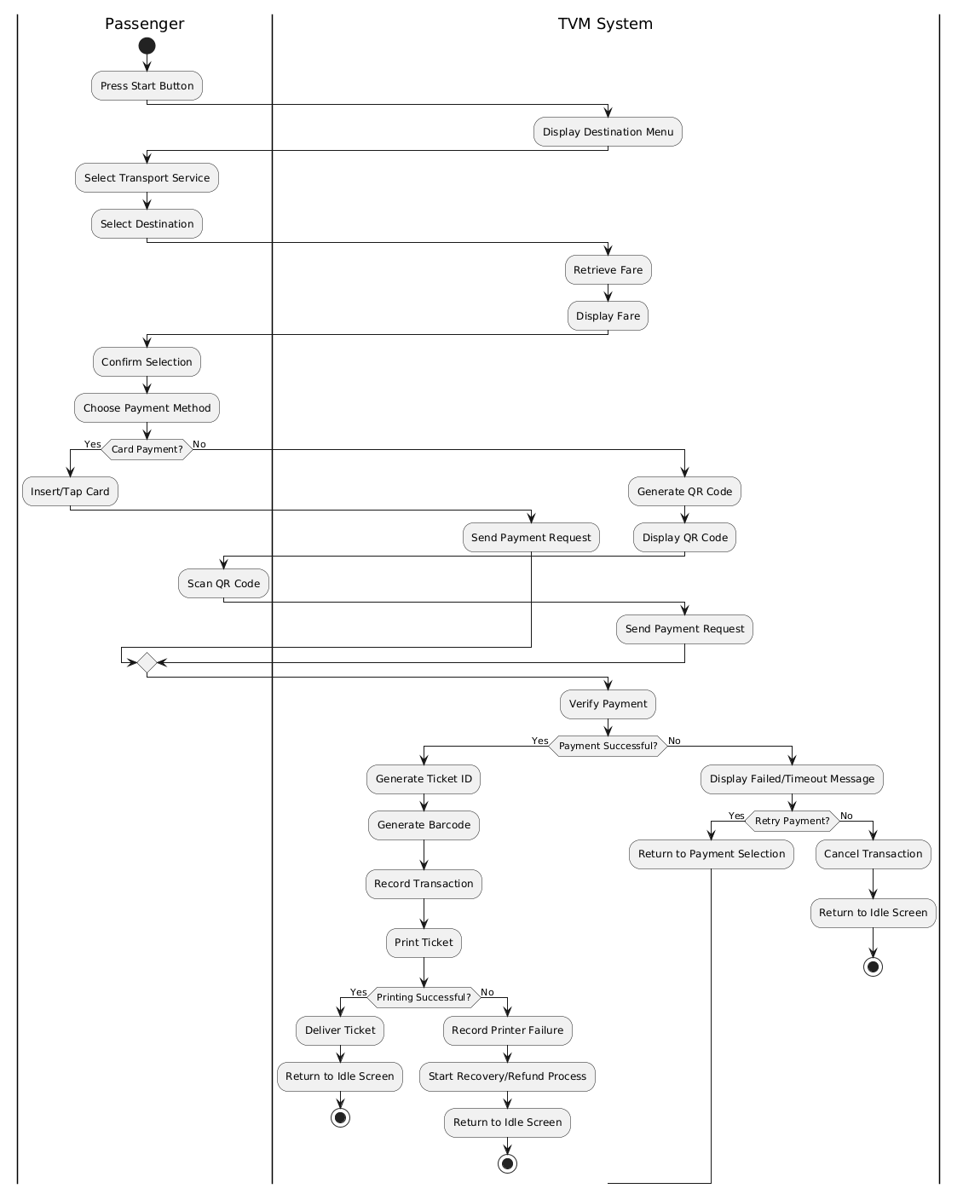

3.2.2 Communication with External Payment Gateways
[ Activity diagram: payment gateway integration ] 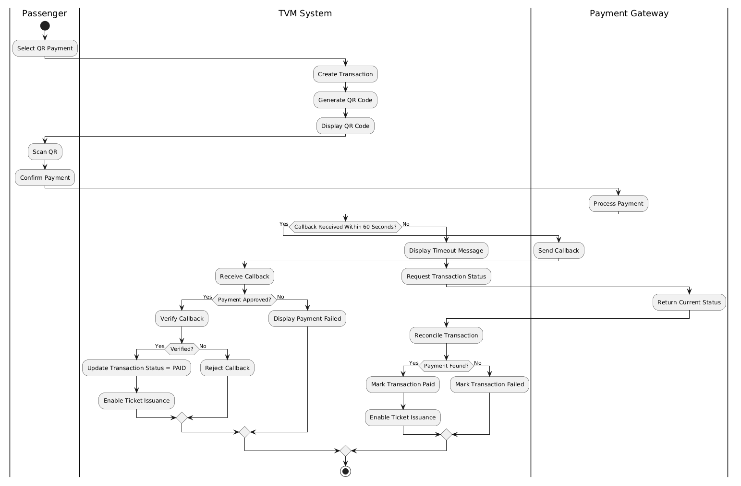

3.3 Detailed System Modeling: Main Use Case "Buy a Ticket" (15 marks)

3.3.1 Sequence Diagram
[ Sequence diagram: Buy a Ticket ] 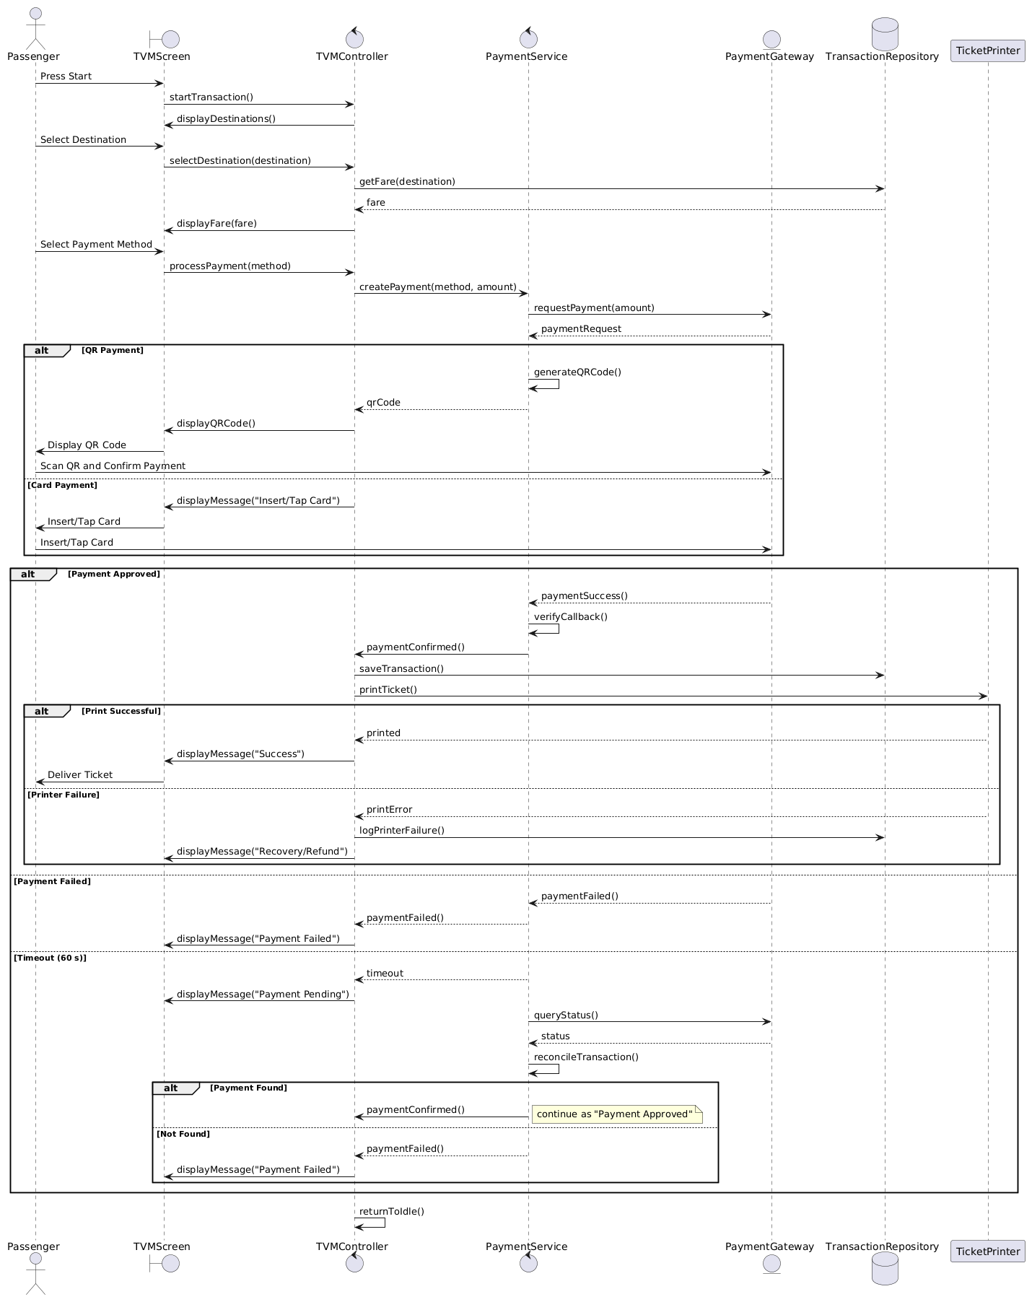

3.3.2 State Chart Diagram
[ State chart diagram ] 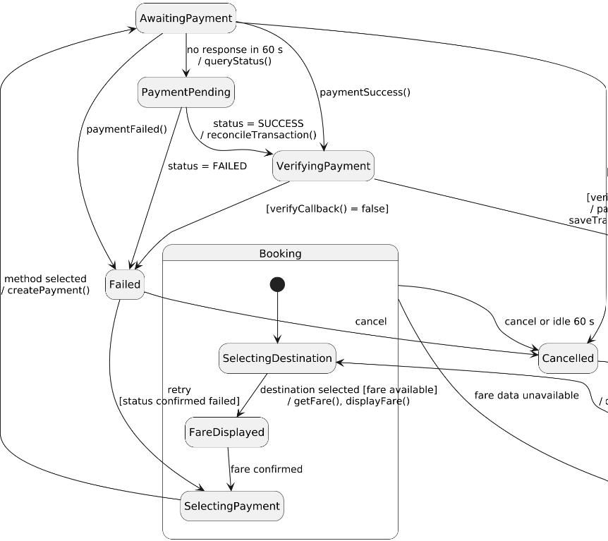
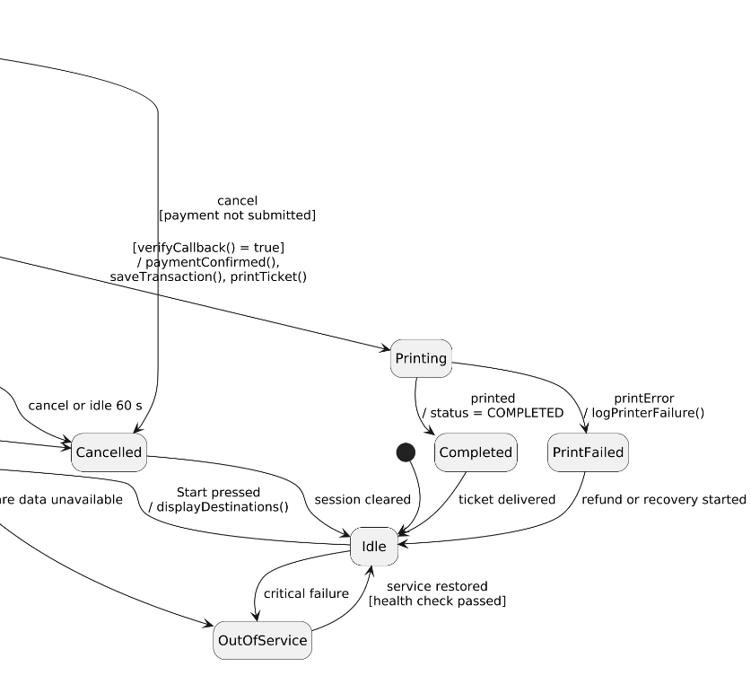

3.3.3 Class Diagram (Domain Model)
[ Class diagram ] 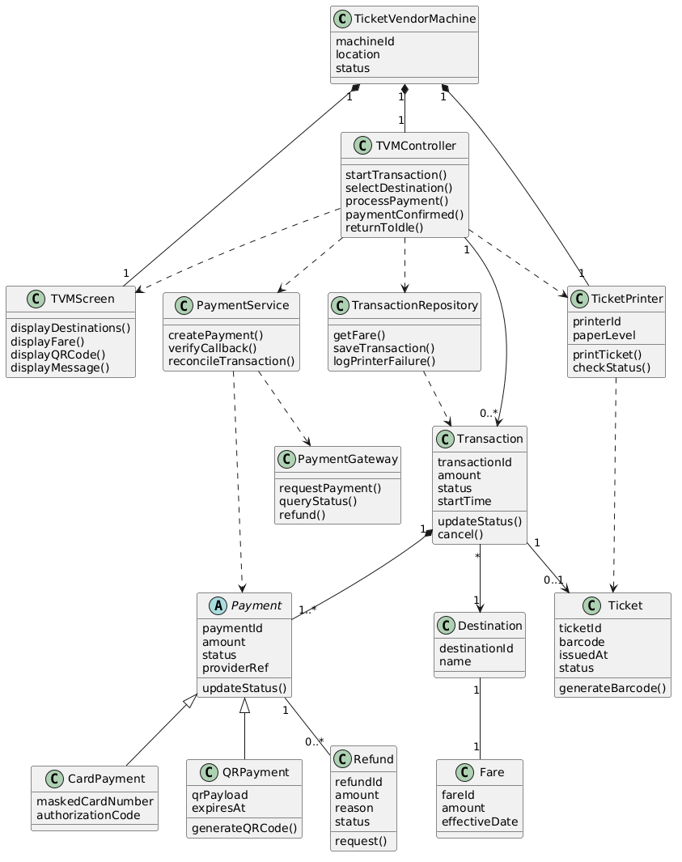
Class | Key attributes | Key methods | Relationships
TicketVendorMachine | machineID, location, status | startTransaction(), displayDestinations(), returnToIdle() | Processes 0..* Transaction; composed of 1 TicketPrinter
Destination | destinationId, name | getFare() | Has 1 Fare; chosen by many Transactions
Fare | fareId, amount, effectiveDate | none | Belongs to 1 Destination
Transaction | transactionId, amount, status, startTime | updateStatus(), cancel() | Handled by 1 TicketVendorMachine; travels to 1 Destination; composed of 1..* Payment; results in 0..1 Ticket
Payment (abstract) | paymentId, amount, status, providerRef | initiate(), verifyResult(), queryStatus() | Part of 1 Transaction; uses PaymentGateway; has 0..* Refund; generalizes CardPayment and QRPayment
CardPayment | maskedCardNumber, authorizationCode | authorize() | Subclass of Payment
QRPayment | qrPayload, expiresAt | generateQR() | Subclass of Payment (covers banking QR and digital wallet)
PaymentGateway | none | requestPayment(), queryStatus(), verifyCallback(), refund() | Used by Payment; represents external providers (VNPay, MoMo, ZaloPay, card acquirer)
Ticket | ticketId, barcode, issuedAt, status | generateBarcode() | Result of 1 Transaction; printed by TicketPrinter
TicketPrinter | printerId, paperLevel | printTicket(), checkStatus() | Part of 1 TicketVendorMachine; prints Ticket
Refund | refundId, amount, reason, status | request() | Belongs to 1 Payment

3.4 Model Consistency Check

Consistency check | Diagrams involved | Done
Every use case in the diagram has a description, and every description is in the diagram | Use case diagram / descriptions | Yes
Every step of the main flow appears in the activity diagram | Descriptions / activity | Yes
Objects and messages in the sequence diagram exist as classes and methods in the class diagram | Sequence / class | Yes
State names and transitions match the events in the sequence diagram | State chart / sequence | Yes
Payment gateway steps match between the two activity diagrams and the sequence diagram | Activity / sequence | Yes
Requirement IDs are cited in the use cases | Requirements / use cases | Yes
The class diagram matches the C# code generated in 5.1 | Class / code | Yes

4. Phase 3: UI/UX & Architecture (15 marks)

4.1 UI/UX Design (5 marks)
Screen | Name / purpose | Linked use case step | Tool and link
S01 | Home / Start: idle screen with Start button and English/Vietnamese toggle | UC00 step 1; alternate 6a (language, UC06); FR1, FR20 | S01-En, S01-Vn [link]
S02 | Destination menu: Metro / Bus tabs and destination list | UC00 steps 2–3; UC01 steps 2–3; FR2, FR3; NFR4 | S02-En-Metro, S02-En-Bus, S02-Vn-Metro, S02-Vn-Bus [link]
S03 | Fare confirmation: service, destination and fare, confirm or change | UC00 steps 4–5; UC01 steps 4–5, alternate 3a; FR4 | S03-En-Metro, S03-En-Bus, S03-Vn-Metro, S03-Vn-Bus [link]
S04 | Payment method: card, banking QR or digital wallet | UC00 step 6; UC02 steps 1–2; FR5 | S04-En, S04-Vn [link]
S05 | Card payment: “Insert or tap your card”, plus card-unreadable variant | UC00 step 7; UC07 steps 1–2, exception 2b; FR6 | S05-En, S05-En-Failed, S05-Vn, S05-Vn-Failed [link]
S06 | QR / wallet payment: QR code, three steps, amount | UC00 step 7; UC08 steps 1–3, exception 3b; FR7; NFR6 | S06-En, S06-Vn [link]
S07 | Please wait: verifying payment, then printing ticket | UC00 steps 9–10; UC09; UC03 steps 1–2; FR8, FR10, FR11; NFR5 | S07-En-Verify, S07-En-Print, S07-Vn-Verify, S07-Vn-Print [link]
S08 | Payment failed: message, Try again or Cancel | UC00 exception 9a (see UC02 exceptions 5a, 5c); FR9, FR13 | S08-En, S08-Vn [link]
S09 | Payment pending: checking status, no retry until reconciled | UC00 exception 9a (see UC02 exception 5b); FR9; NFR6 | S09-En, S09-Vn [link]
S10 | Ticket issued: success, ticket summary, auto-return | UC00 step 11; UC03 step 4; FR16 | S10-En, S10-Vn [link]
S11 | Printing failed: error, refund started, reference number | UC00 exception 10a; UC04 steps 3–5; FR14 | S11-En, S11-Vn [link]
S12 | Cancel / session expired: confirm pop-up, cancelled, expired | UC00 alternate 5a (cancel or 60 s idle, UC05); FR15, FR16, FR17 | S12-En-Confirmation, S12-En-Cancelled, S12-En-Expired, S12-Vn-Confirmation, S12-Vn-Cancelled, S12-Vn-Expired [link]
S13 | Out of service: machine unavailable | UC00 and UC01 exception 4a; UC04 exception 5a; FR19 | S13-En, S13-Vn [link]
S14 | Maintenance (staff only): status list, health check pass or fail | UC10 steps 1–4, exception 3a; NFR9 | S14-En, S14-En-CheckPass, S14-En-CheckFailed, S14-Vn, S14-Vn-CheckPass, S14-Vn-CheckFailed [link]

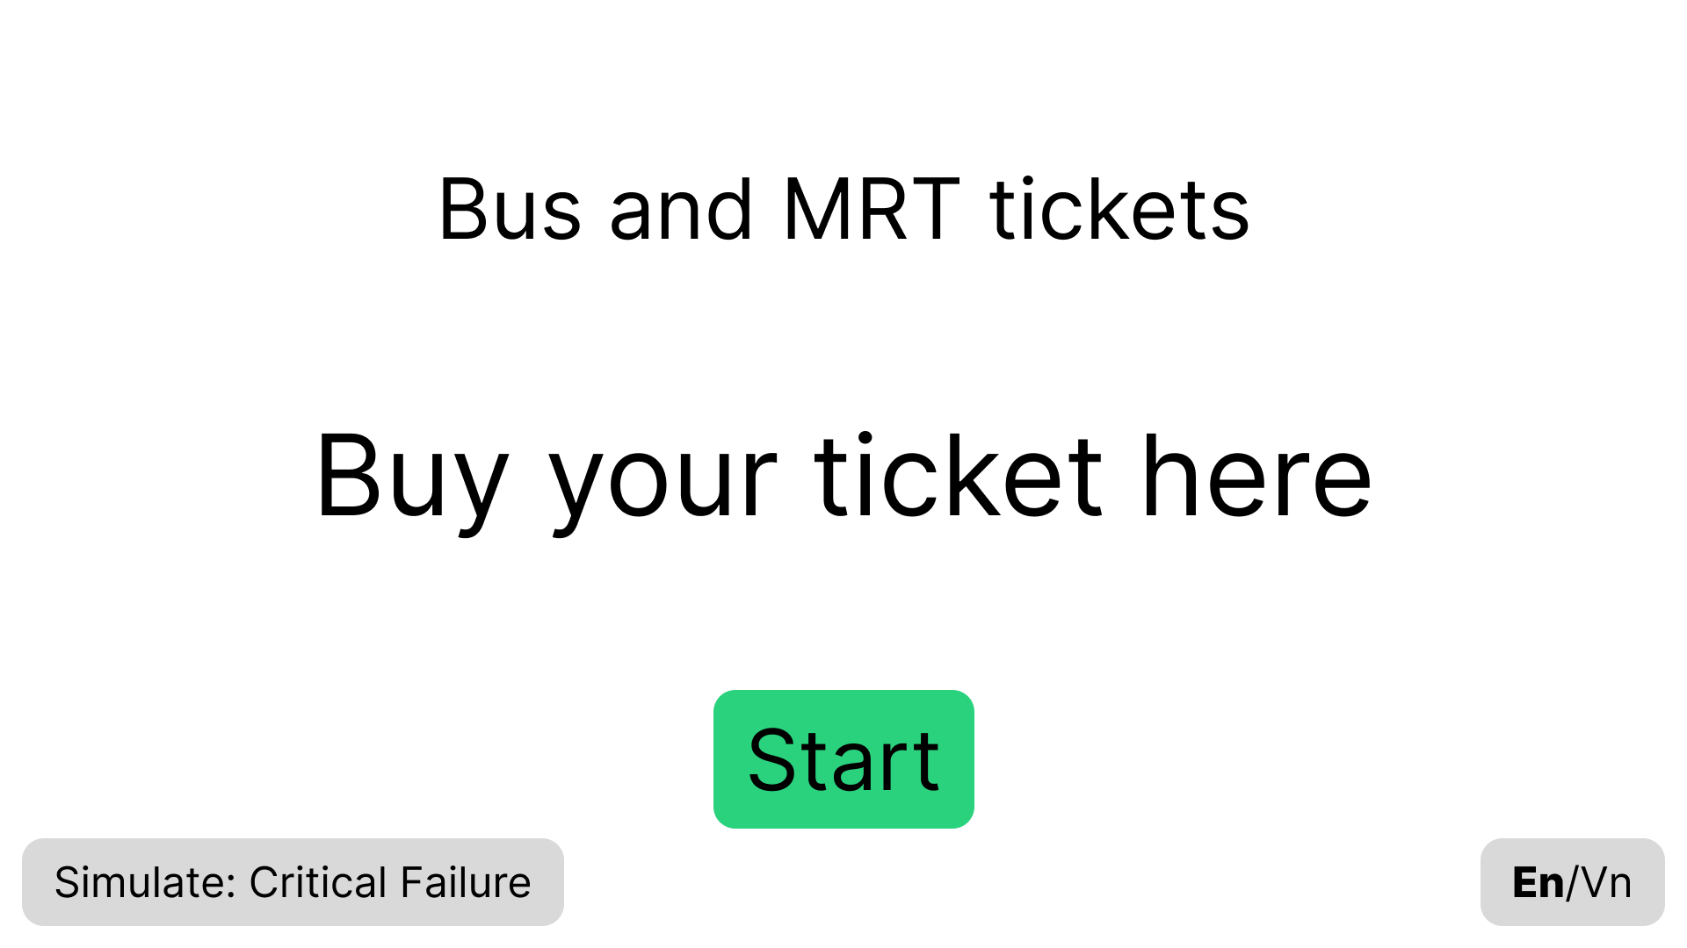
S01-En

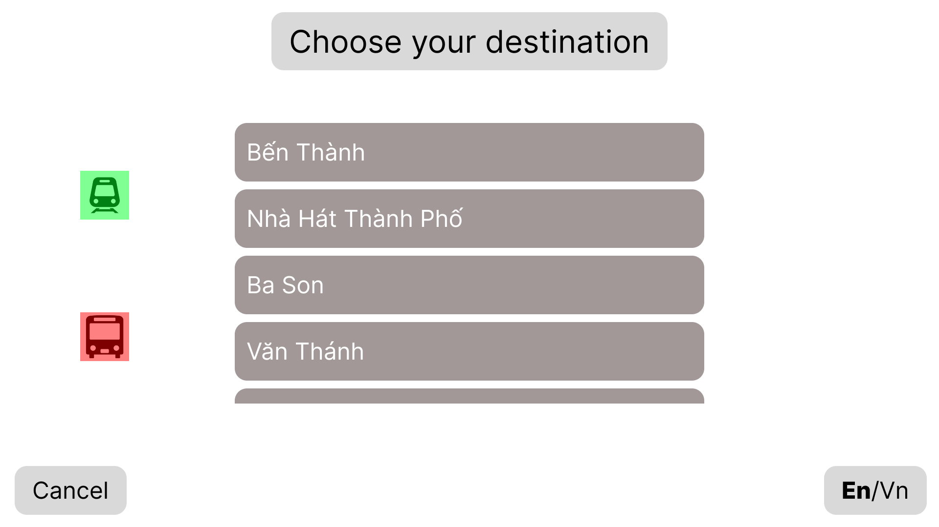
S02-En-Metro
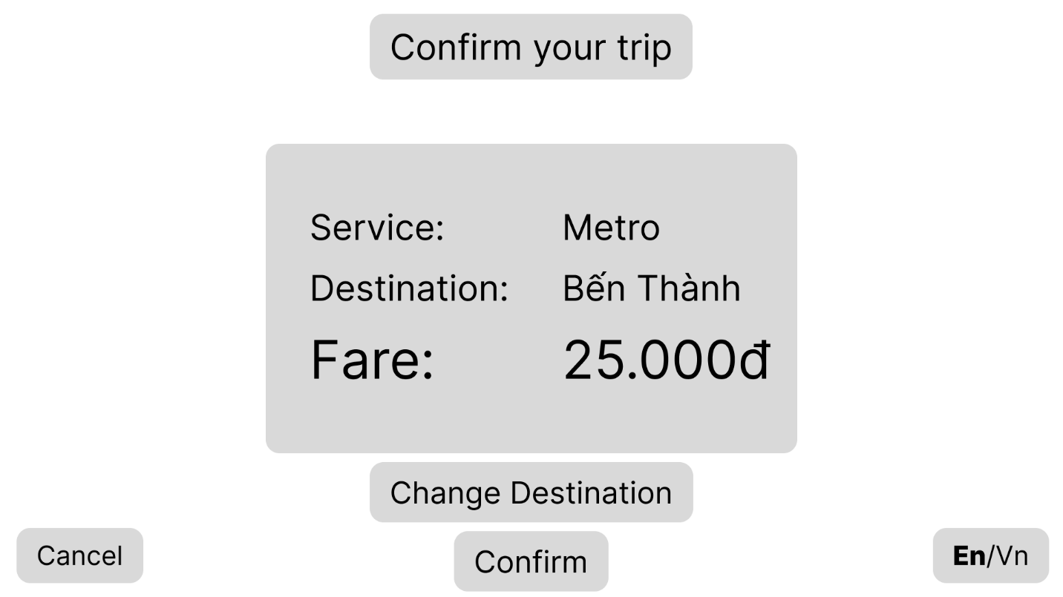
S03-En-Metro

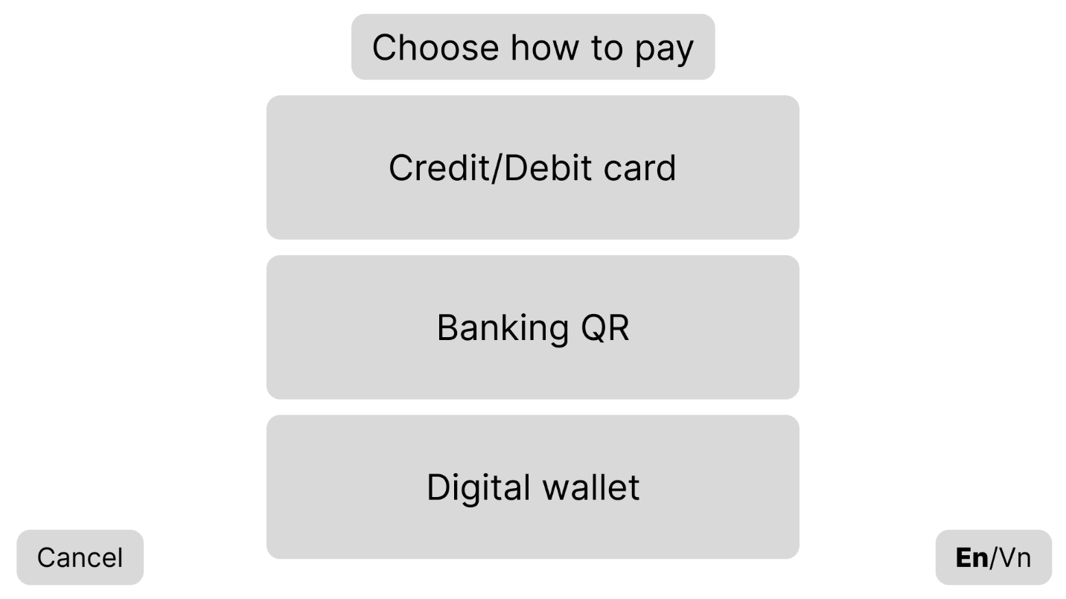
S04-En
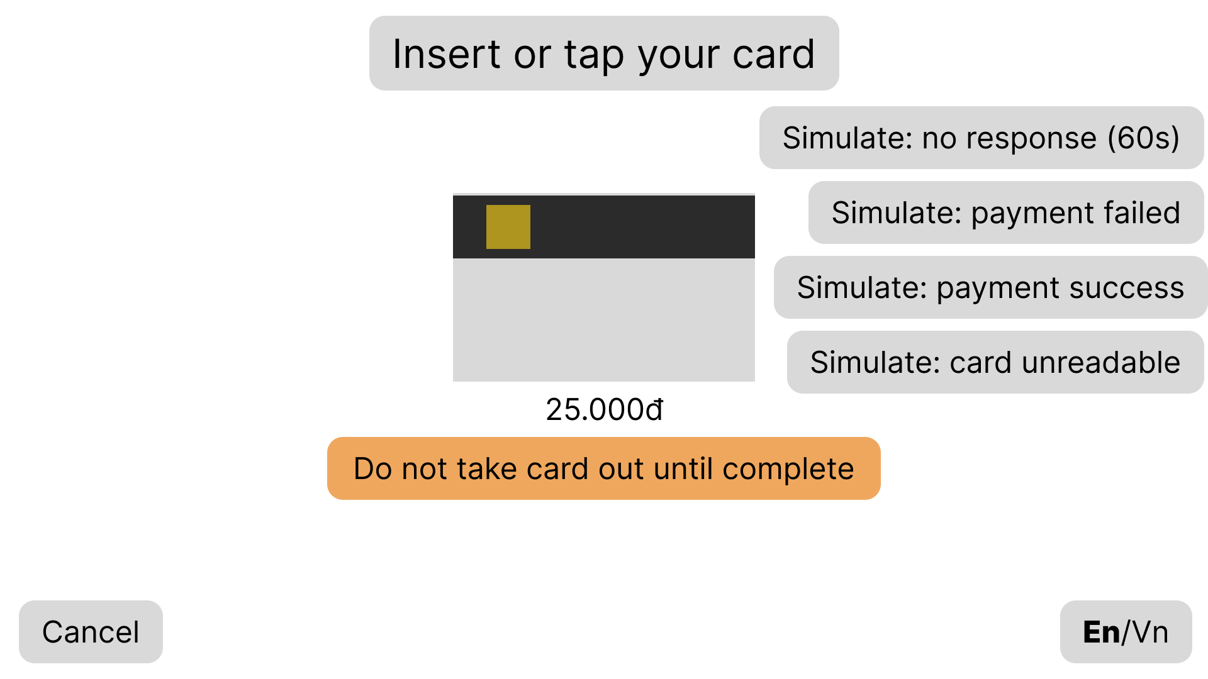
S05-En

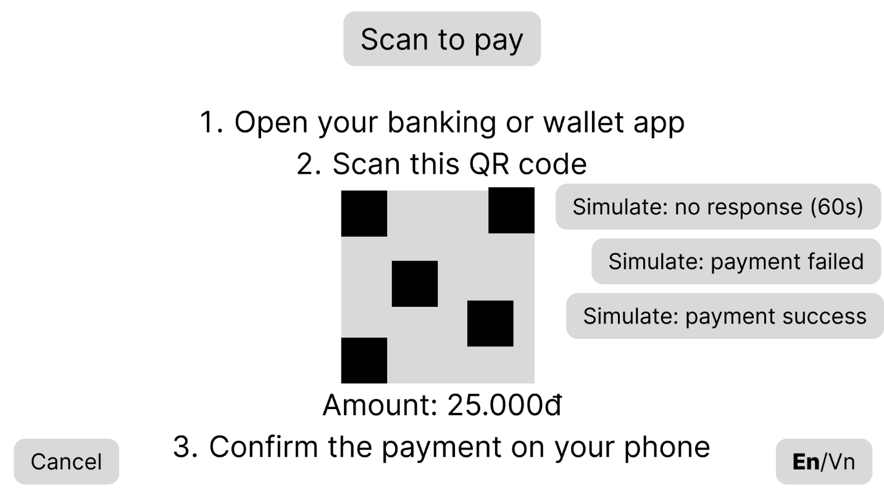
S06-En
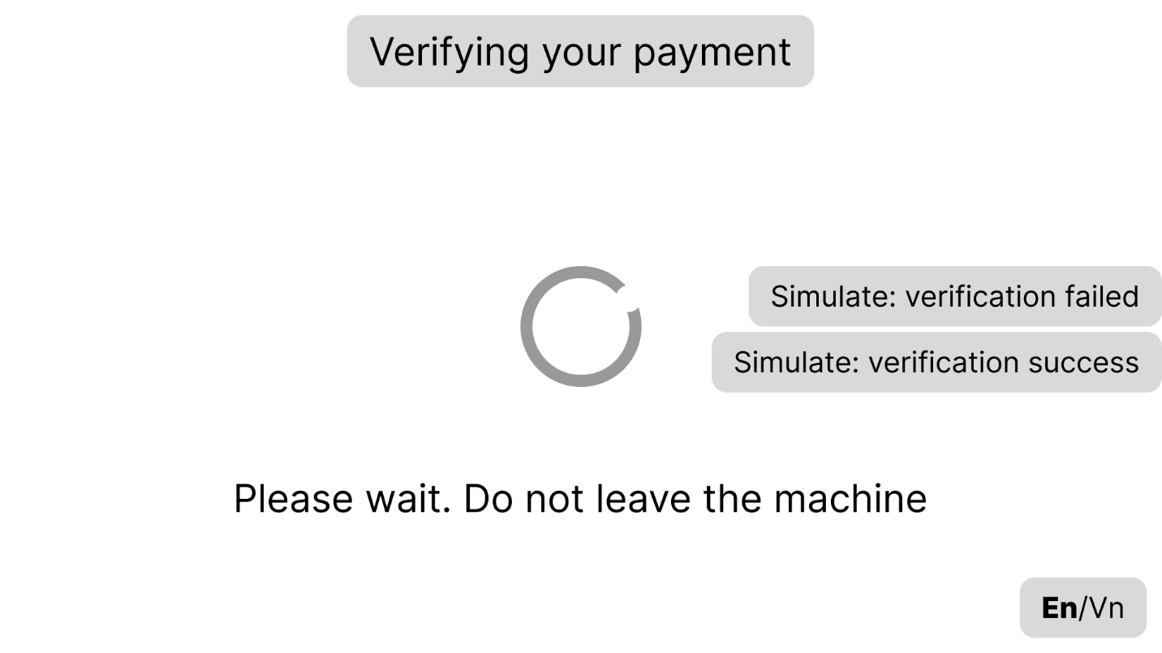
S07-En-Verify

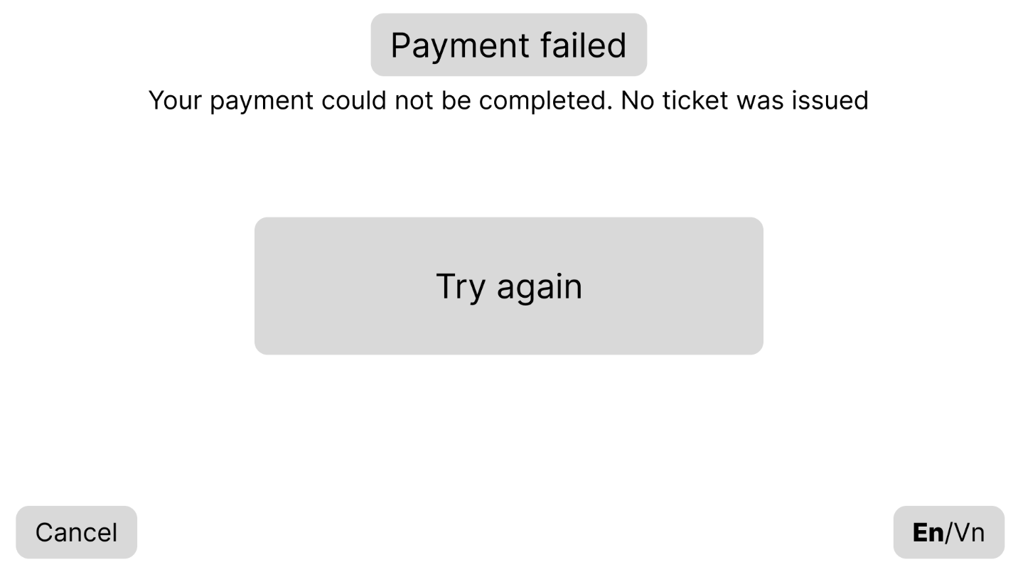
S08-En
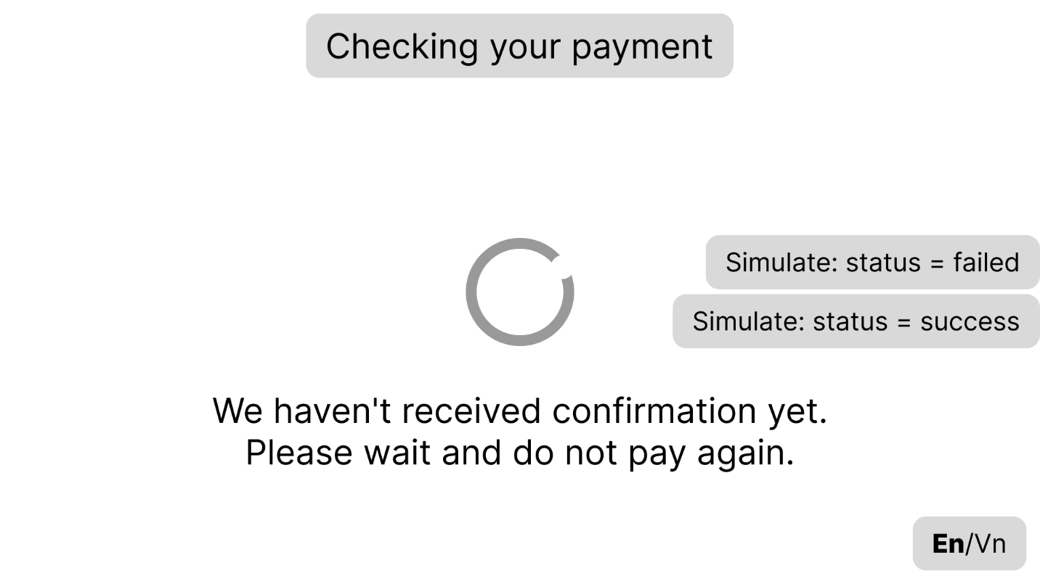
S09-En

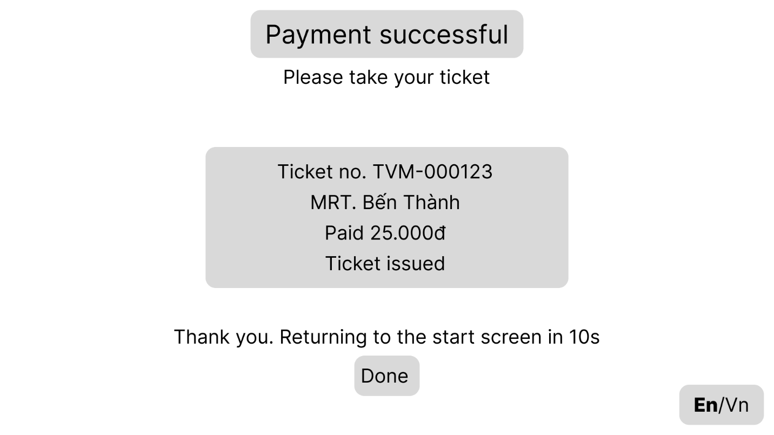
S10-En
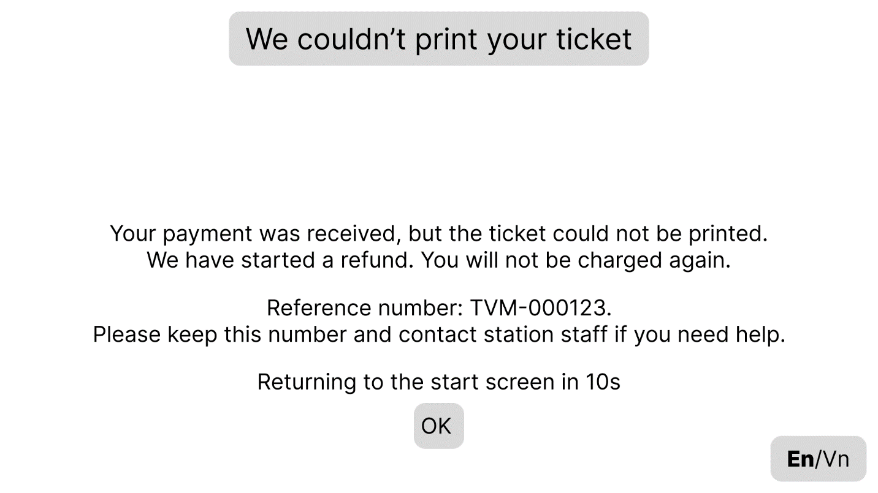
S11-En

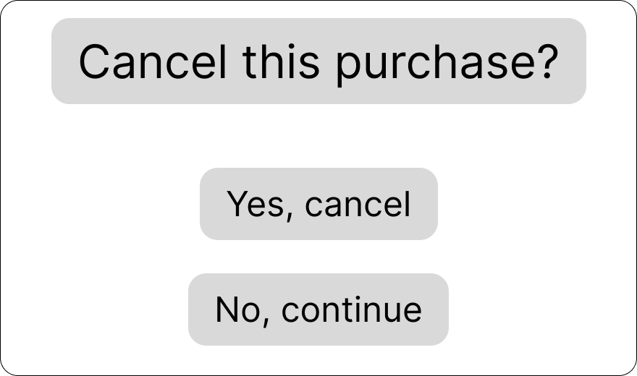
S12-En-Confirmation
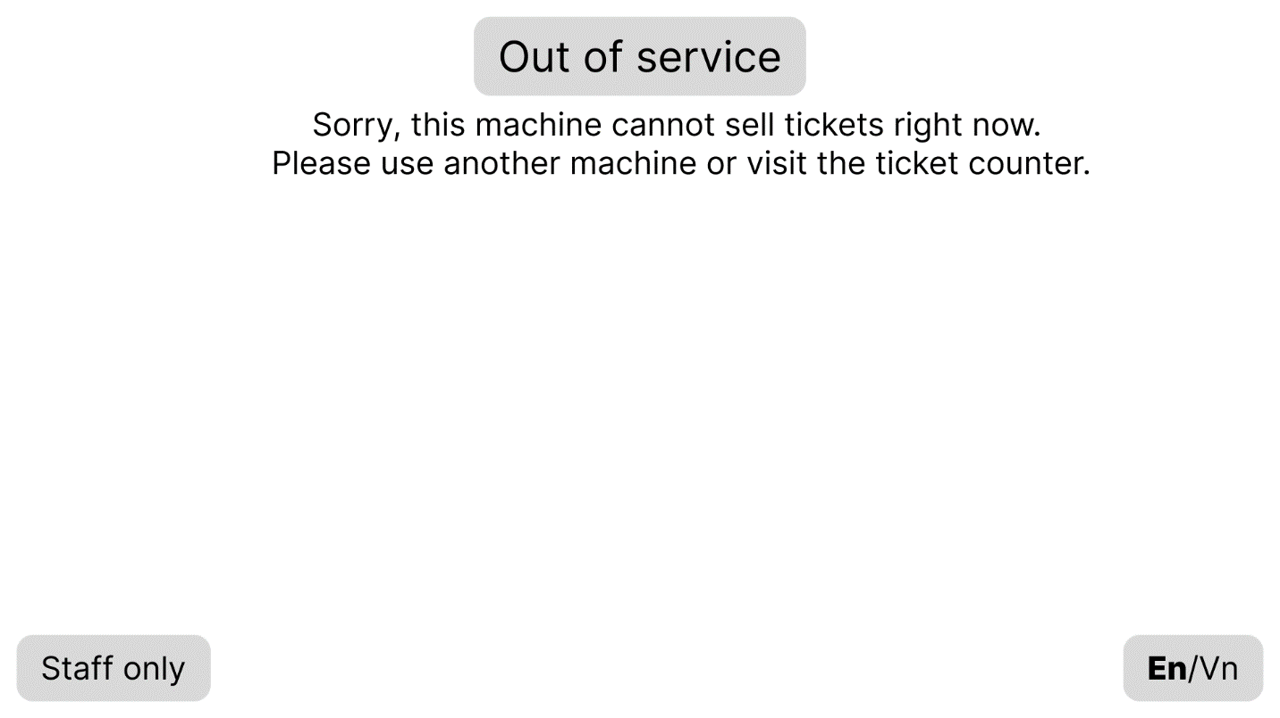
S13-En

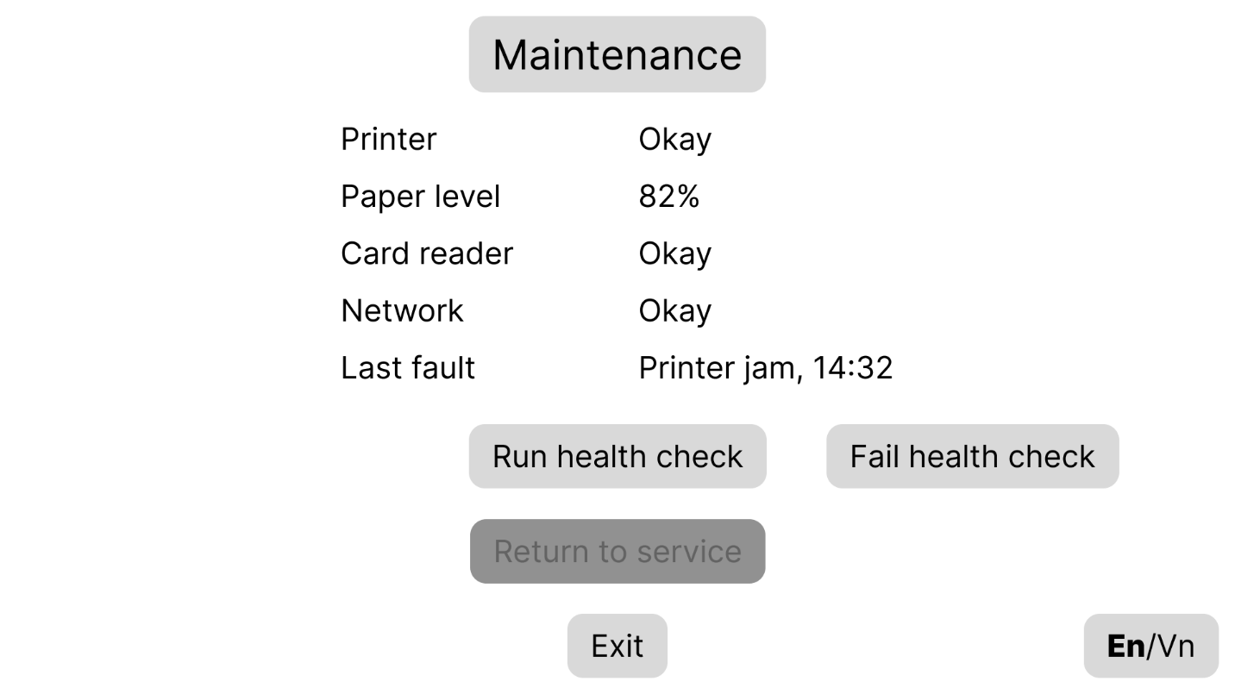
S14-En

4.2 Architectural Design (10 marks)

4.2.1 Architecture Diagram
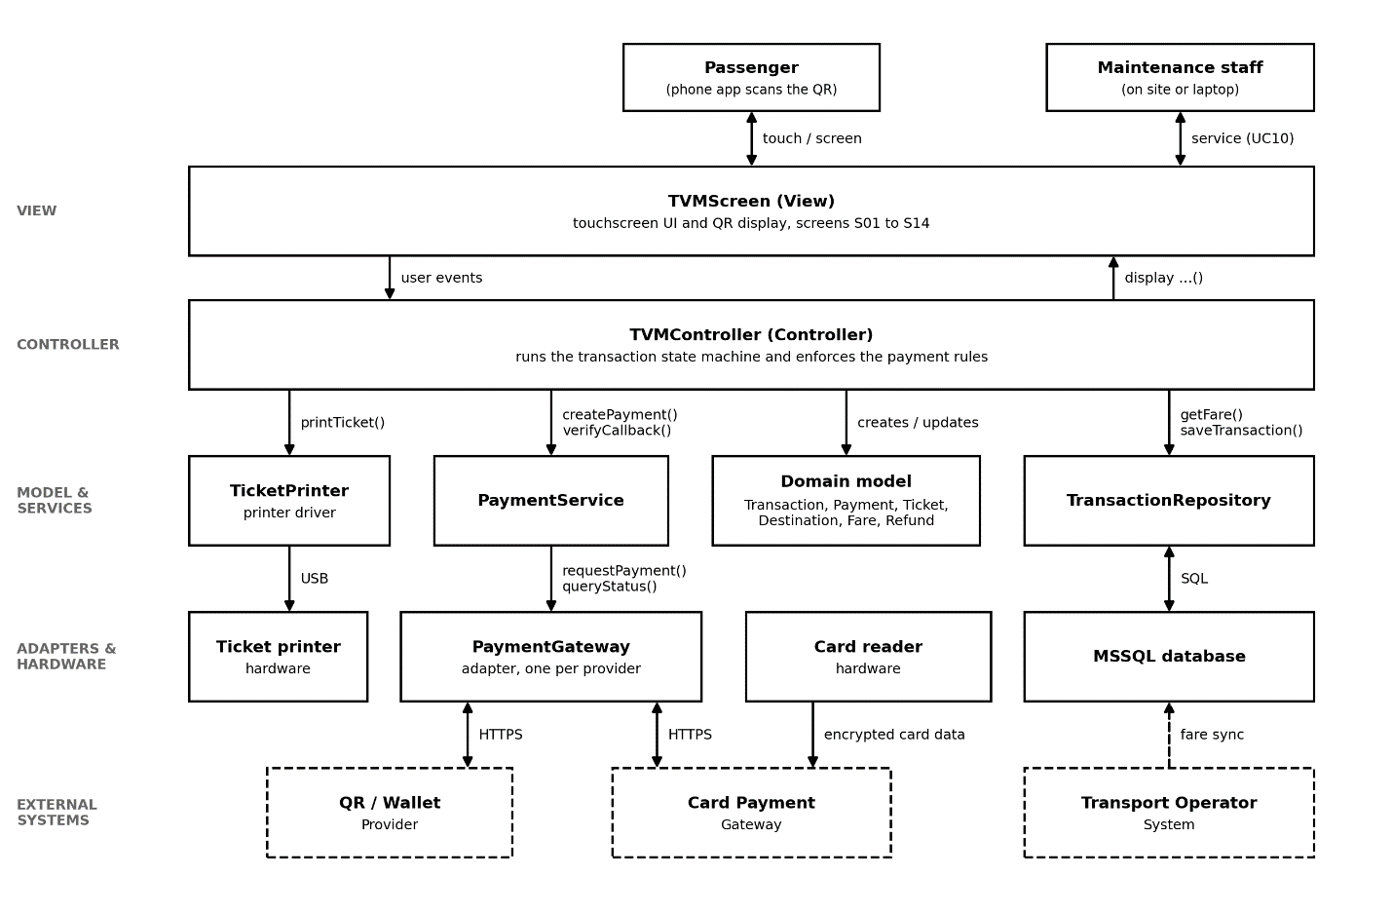
TVM architecture diagram (layered MVC)
The TVM is built as a layered MVC application, as shown in the Figure 4.2.1 above. The View (TVMScreen) is only the touchscreen interface (screens S01 to S14). It only displays information and passes the passenger’s actions on. The Controller (TVMController) is the only part that decides what happens next. It follows our state chart and enforces the main rules: no ticket until payment is verified, a 60 second limit on waiting for a payment result, and retry only after a confirmed failure. The Model is the set of domain classes from our class diagram (Transaction, Payment, Ticket, Destination, Fare and Refund), supported by PaymentService and TransactionRepository. Everything outside the application sits behind an adapter: PaymentGateway talks to the card and QR/wallet providers, TicketPrinter to the printer, and the repository to the MSSQL database. We chose this structure because it keeps screens, rules and integrations separate. A screen or provider can change without touching the rest, and a printer or gateway failure is handled in one place instead of breaking the whole machine.

4.2.2 Deployment Diagram
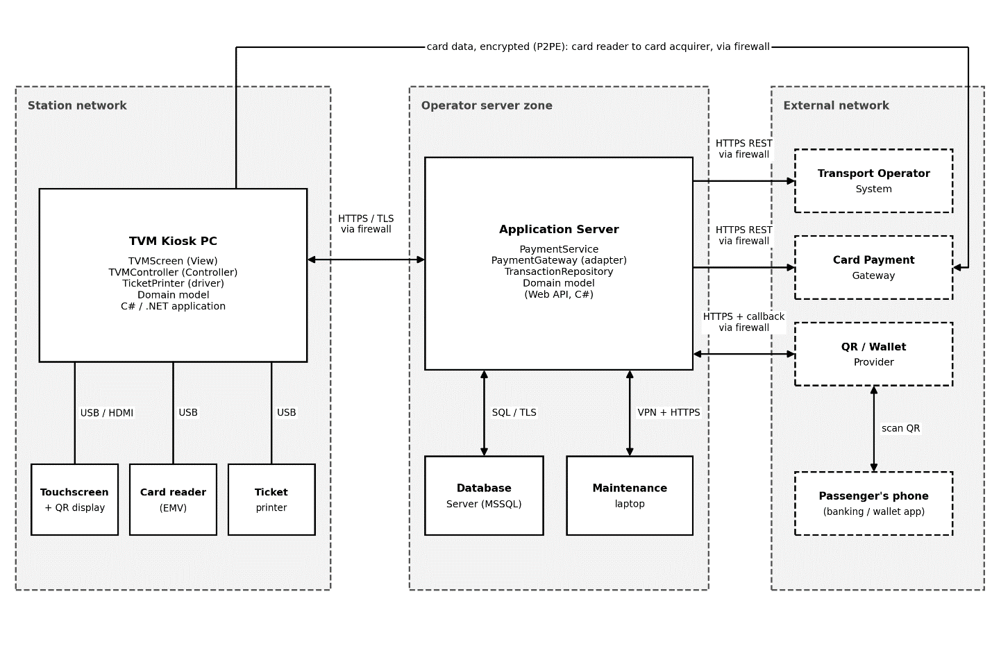
TVM deployment diagram
Node / component | Description | Connection (protocol, direction)
TVM Kiosk PC (TVM hardware) | Kiosk computer at the station running the TVM application (TVMScreen, TVMController, TicketPrinter, and Domain model). Includes the staff-only maintenance screens (S13, S14) for on-site service (UC10). | USB/HDMI to the peripherals; HTTPS/TLS to the application server, two-way, via firewall; kiosk initiates and polls for payment status
Touchscreen + QR display | Passenger input; shows the menus and the QR code | USB/HDMI to the kiosk PC, two-way
Card reader (EMV) | Reads or taps the card and encrypts the data (P2PE); the application never sees the card number | USB/serial to the kiosk PC; TLS outbound directly to the card acquirer
Ticket printer | Prints the ticket with its barcode; reports errors and paper out | USB from the kiosk PC; print commands out, status back
Application server | Hosts PaymentService, and PaymentGateway (adapter), TransactionRepository, and the Domain model (Web API, C#); receives provider callbacks, verifies the signature, reconciles status, records transactions | Inbound HTTPS from the kiosk and from QR/wallet callbacks; outbound HTTPS REST to gateways and the operator; SQL over TLS to the database; VPN + HTTPS from the maintenance laptop
Database server (MSSQL) | Transactions, payments, tickets, refunds, fares, destinations, logs | SQL over TLS from the application server only, two-way; not reachable from the kiosk or the internet
Payment gateway API: card (Card Payment Gateway) | Card acquirer that authorises card payments | TLS direct from the card reader (authorisation); HTTPS REST outbound from the application server (status query, refund), via firewall
Payment gateway API: QR / wallet | Creates and confirms QR and wallet payments | HTTPS REST outbound from the application server; signed callback inbound to the application server, via firewall
Transport Operator System | Authoritative fares and destinations (DR1, DR2); ticket validation | HTTPS REST outbound from the application server, via firewall
Passenger’s phone | Banking or wallet app that scans the QR shown on the TVM screen | Mobile data, HTTPS to the QR/wallet provider; not connected to the TVM
Maintenance laptop | Staff tool for UC10: fault logs and health checks | VPN + HTTPS to the application server, two-way
Firewalls | Mark the network boundaries between the station, the server zone and the internet | Allow-listed traffic only; only the callback endpoint is exposed inbound

5. Phase 4: Implementation, Tooling & Demo (30 marks)

5.1 Visual Studio Engineering: Model-to-Code (10 marks)

5.1.1 Forward Engineering (Model to Code)
[Generated code skeleton from the Model]
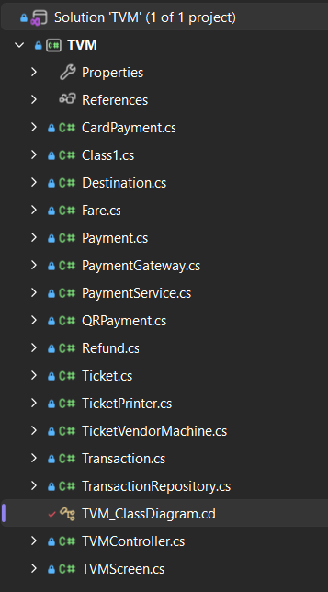

[The Model]
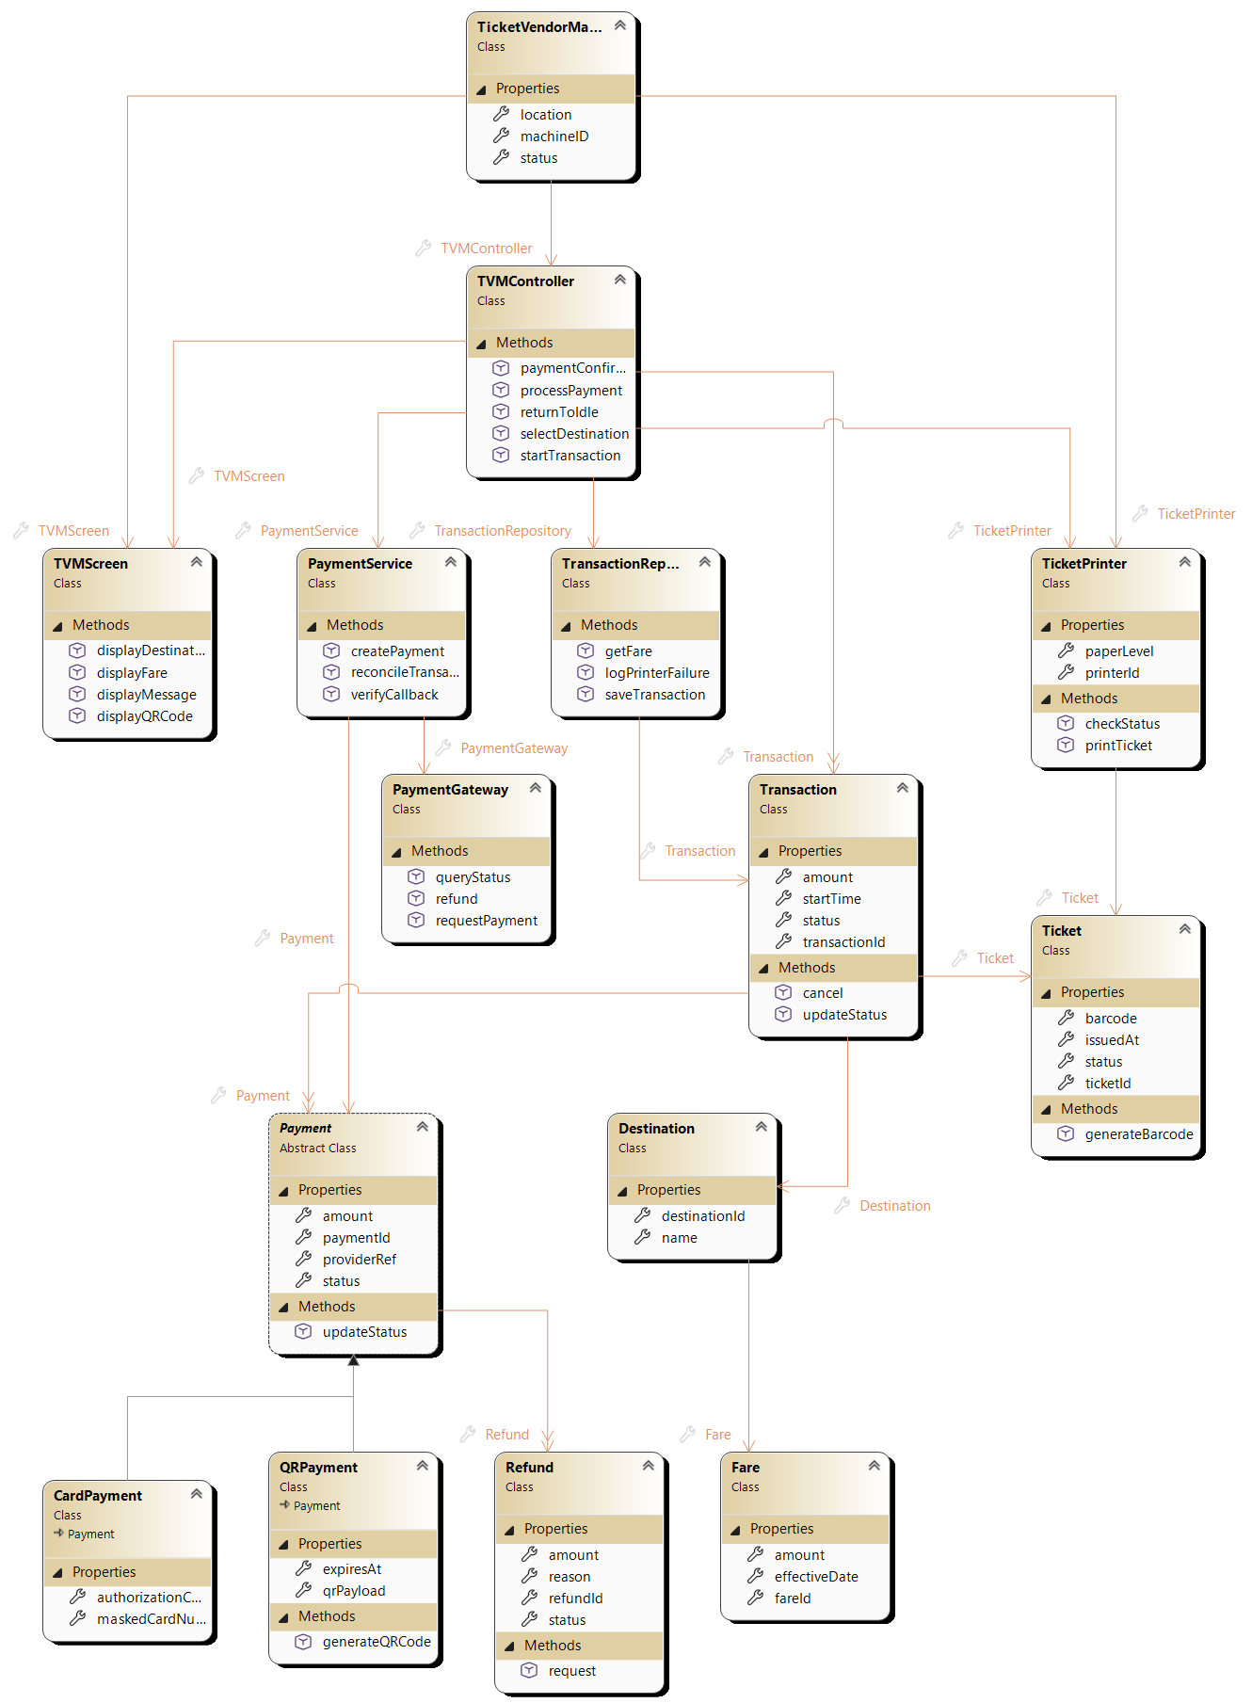
No. | The steps | What Visual Studio generated
1 | Created a Class Library project and added TVM_ClassDiagram.cd with Class Designer | Project and diagram file
2 | Added the 15 classes from Figure 3.3.3 using the Toolbox (Payment as an abstract class) | One .cs file per class
3 | Entered attributes and methods in Class Details | Properties and method stubs (NotImplementedException)
4 | Drew inheritance for CardPayment and QRPayment | : Payment declarations
5 | Connected the other classes with the Association tool, using List<T> for one-to-many | Properties of the target class type, and List<T> collections

5.1.2 Backward Engineering (Code to Model)
No. | Manual code change | File / class | How it was reflected in the model
1 | Added the TransactionStatus enum (Created, Pending, Paid, Failed, Completed, Cancelled) and changed Transaction.status from string to TransactionStatus (state chart states) | TransactionStatus.cs, Transaction.cs | New enum box on the diagram, with an association line from Transaction; status now shows the new type
2 | Added the PaymentStatus enum (Initiated, Pending, Verified, Failed, TimedOut) and changed Payment.status to use it (FR9) | PaymentStatus.cs, Payment.cs | New enum box, with an association line from Payment
3 | Changed generateQRCode() to return string and added isExpired() to check the 60 second QR limit (NFR6) | QRPayment.cs | Changed signature and one new method in the QRPayment box
4 | Added the constructor Transaction(string transactionId, decimal amount) that sets the initial status and start time | Transaction.cs | Constructor listed in the Transaction box
5 | Added the TicketStatus enum (Issued, Printed, PrintFailed, Refunded) and changed Ticket.status to use it (FR14) | TicketStatus.cs, Ticket.cs | New enum box, with an association line from Ticket
6 | Added the IPaymentGateway interface and made PaymentGateway implement it (adapter design from Section 4.2) | IPaymentGateway.cs, PaymentGateway.cs | New interface box; PaymentGateway shows the implemented interface as a labelled circle connected to the class
7 | Implemented updateStatus(TransactionStatus newStatus) and cancel() with real bodies | Transaction.cs | updateStatus now shows its new parameter in the Transaction box
8 | Added isPaperLow() to detect low paper before printing (FR14) | TicketPrinter.cs | New method in the TicketPrinter box
9 |  | Ticket.cs
  Implemented generateBarcode() to return a barcode string built from the ticket ID (FR10)
  Return type changed from void to string in the Ticket box
10 | Changed Payment.updateStatus() to take a PaymentStatus parameter and set the payment’s status | Payment.cs | Updated signature in the Payment box
11 | Implemented printTicket(Ticket) and checkStatus(), with a print-failure path when paper is low (UC04) | TicketPrinter.cs | printTicket now shows its Ticket parameter and bool return type
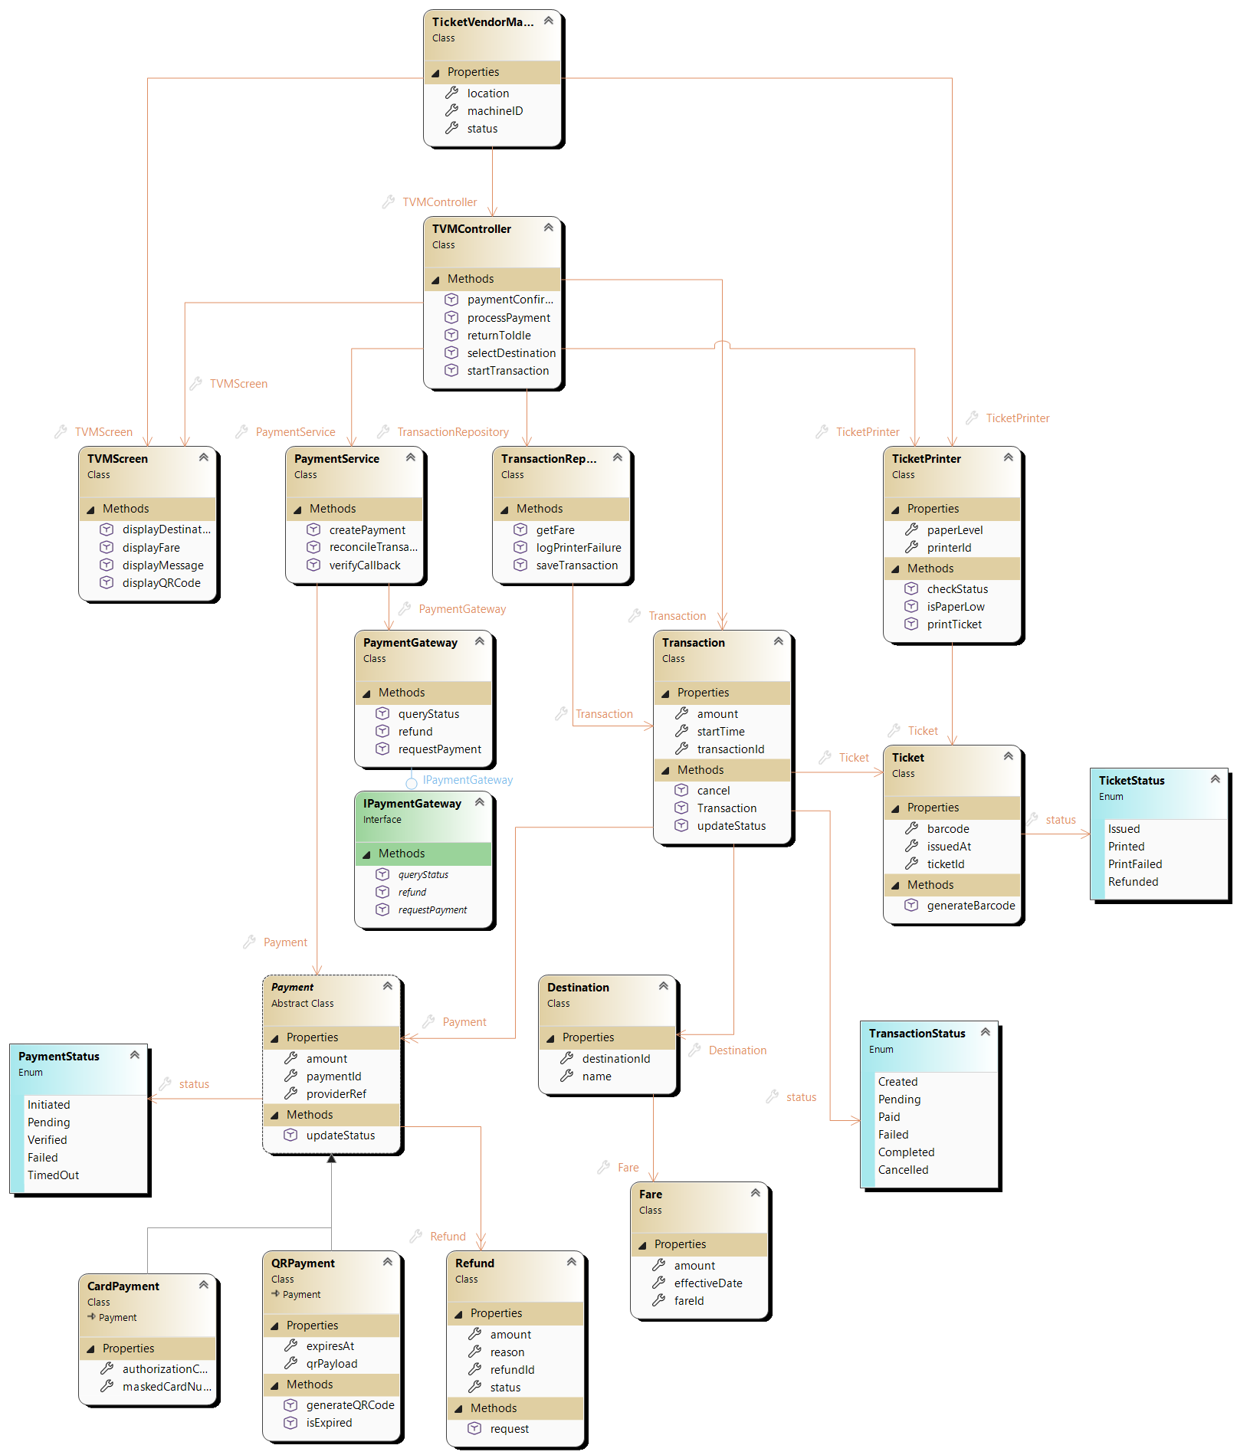

5.1.3 Code Map
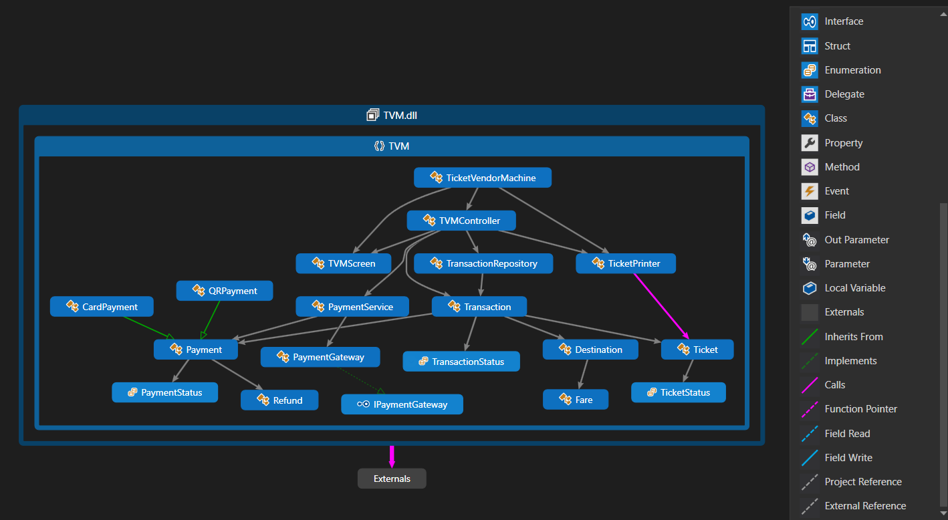
The code map generated from the TVM assembly shows the 15 domain classes, the three status enums and the IPaymentGateway interface. TicketVendorMachine sits at the top and depends on TVMController, TVMScreen and TicketPrinter, matching the composition in Figure 3.3.3. TVMController has the most outgoing links, to TVMScreen, TransactionRepository, TicketPrinter, PaymentService and Transaction, which confirms its role as the single coordinator in our layered MVC architecture. CardPayment and QRPayment inherit from Payment, and PaymentGateway implements IPaymentGateway, so payment providers stay behind an adapter. References to .NET framework types are grouped under Externals and hidden to keep the map focused on the TVM classes.

5.2 GitHub & AI Tooling (10 marks)

5.2.1 Source Control
Item | Your answer
Repository link | https://github.com/plDucTri/Ticket-Vendor-Machine
Branches (names and purpose) | main: the only branch. It is the default branch and holds all four phase folders. Members committed directly to it.
Number of commits and pull requests | 11 commits

Member | Commits | Pull requests | Main contributions
Pham Minh Tai | 1 | 0 | Phase 1: uploaded the Requirements Engineering report (docx).
Vu Hoang Phuc | 1 | 0 | Phase 2: uploaded the UML Modeling & System Design report (docx).
Truong Minh Quang | 1 | 0 | Phase 3: uploaded the UI/UX & Architecture report (docx) and figma file.
Pham Le Duc Tri | 7 | 0 | Created folders for 4 phases, committed the class diagram before and after engineering, and the Code Map to Phase 4.
Nguyen Ngoc Nhat Minh |  | 0 | Finishes Phase 4: the demo.

5.2.2 AI Assistance: Copilot Prompt Documentation
No. | Member | Prompt | How the AI helped | Used? (kept / changed / rejected) | How we validated it
1 | Pham Le Duc Tri | “My toolbox only has pointer, class, enum, interface, abstract class, struct, delegate, inheritance and association.” | Class Designer has no Composition tool, so composition and dependencies are drawn with Association | Kept | It made sense to use Association since the toolbox does not have composition
2 | Pham Le Duc Tri | “Guide me through the backward engineering” | Generated boilerplate for the enums, the IPaymentGateway interface, the Transaction constructor and the method bodies | Kept | Built after each change and checked that every edit appeared in the class diagram
3 | Pham Le Duc Tri | “Why is get => default a problem?” | Explained that the generated stub returns the default value and ignores assignments, so values are never stored. Then gave a PowerShell script to change every stub to { get; set; } | Kept | Ran the script, searched for get => default, and rebuilt with 0 errors

5.2.3 Reflection on AI Use

5.3 Demo Application (10 marks)
Item | Your answer
Technology and versions | C# WinForms, .NET Framework 4.7.2, Visual Studio ,SQL Server, System.Data.SqlClient
Database script location and how to run it | Get TVMDemo and database.sql from Github. Open it in SSMS, connect to your server, press F5. It creates TVMDemo with sample data.
How to run the application | Open TVM.slnx, set TVMDemo as the startup project and change the server name in App.config to match your SSMS server. Then press F5.
Video demo link (optional) | [ ]
Input form
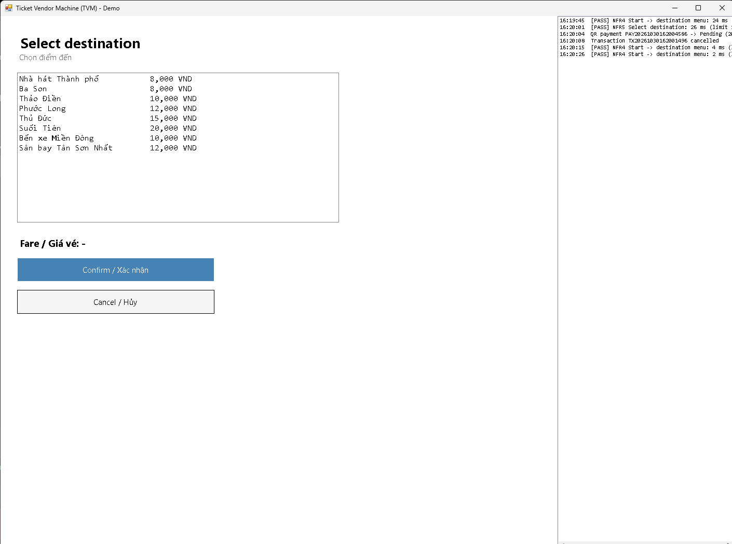
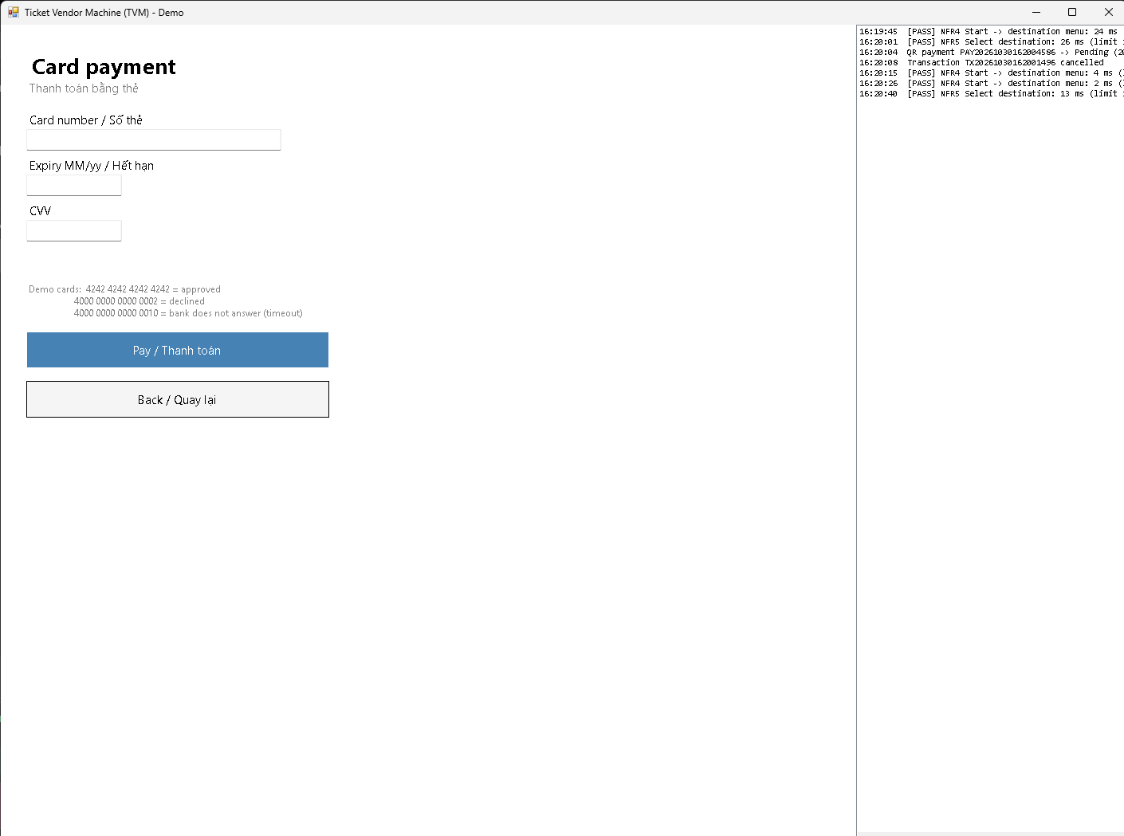
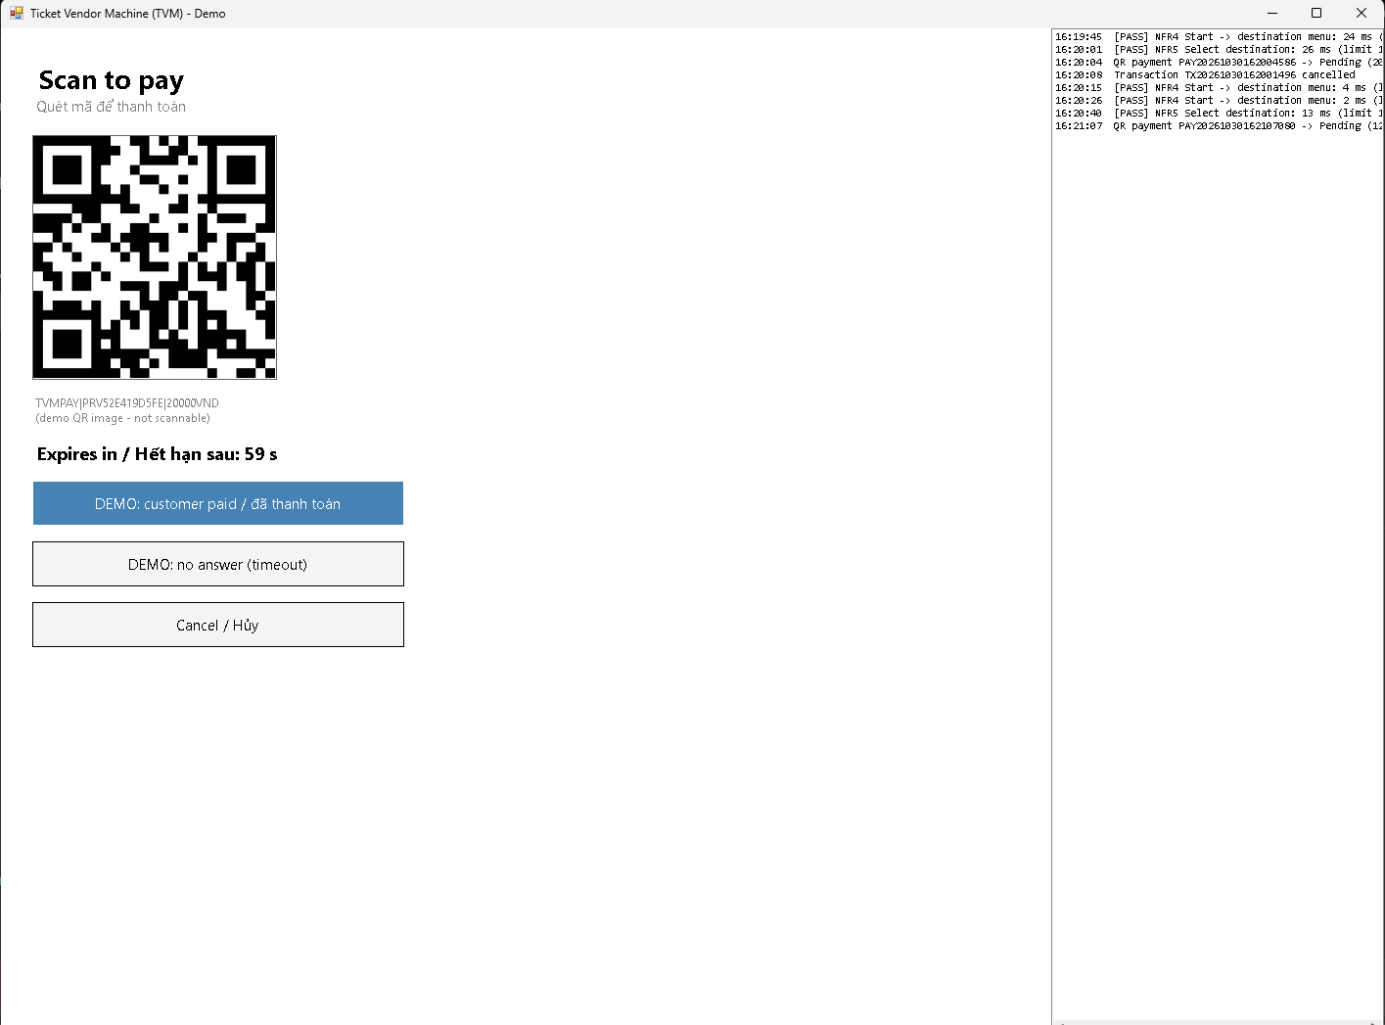
Output report or success screen
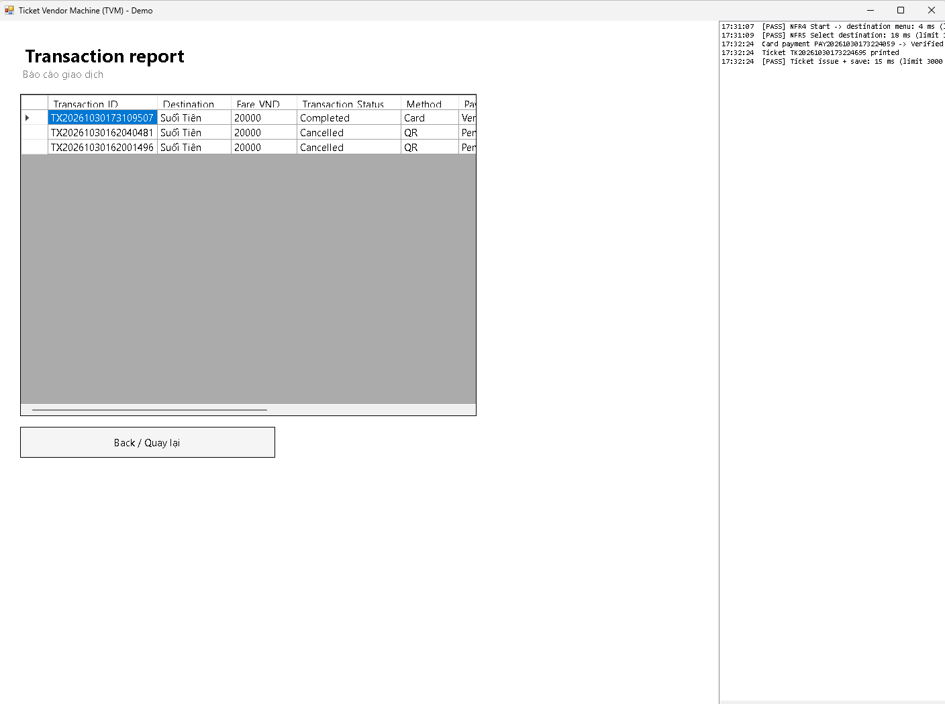
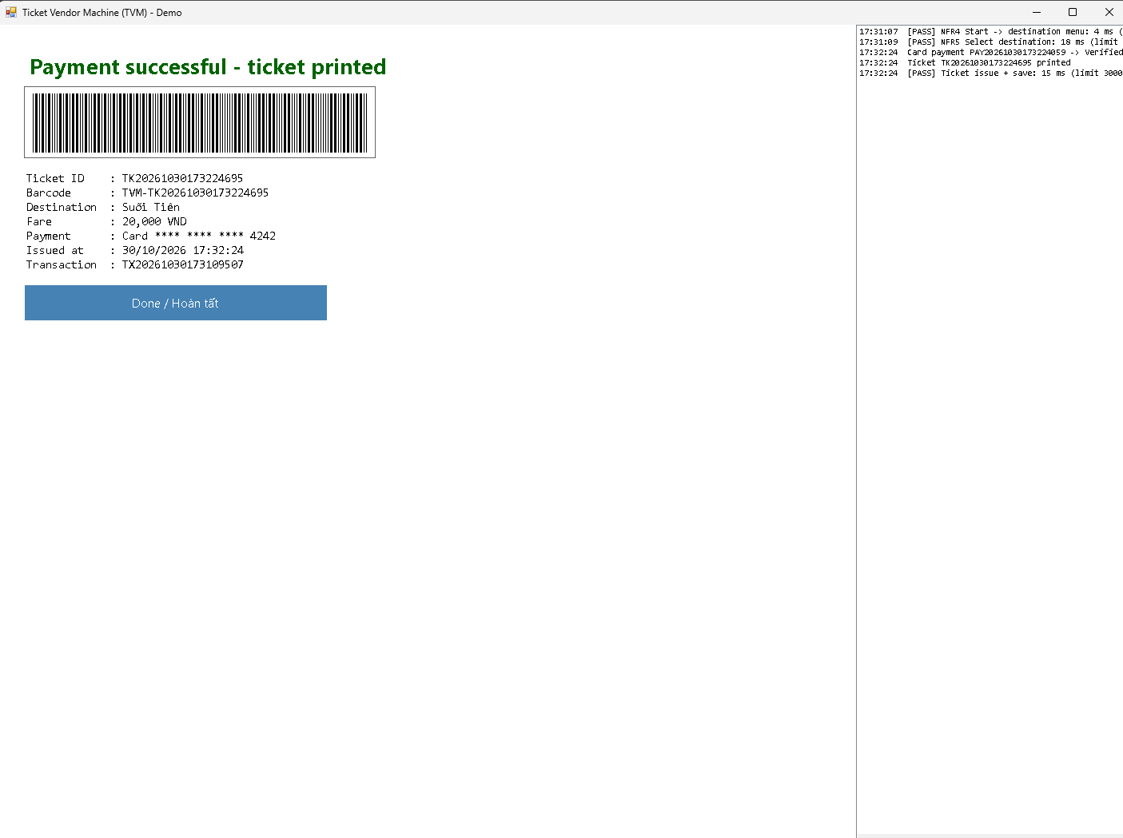
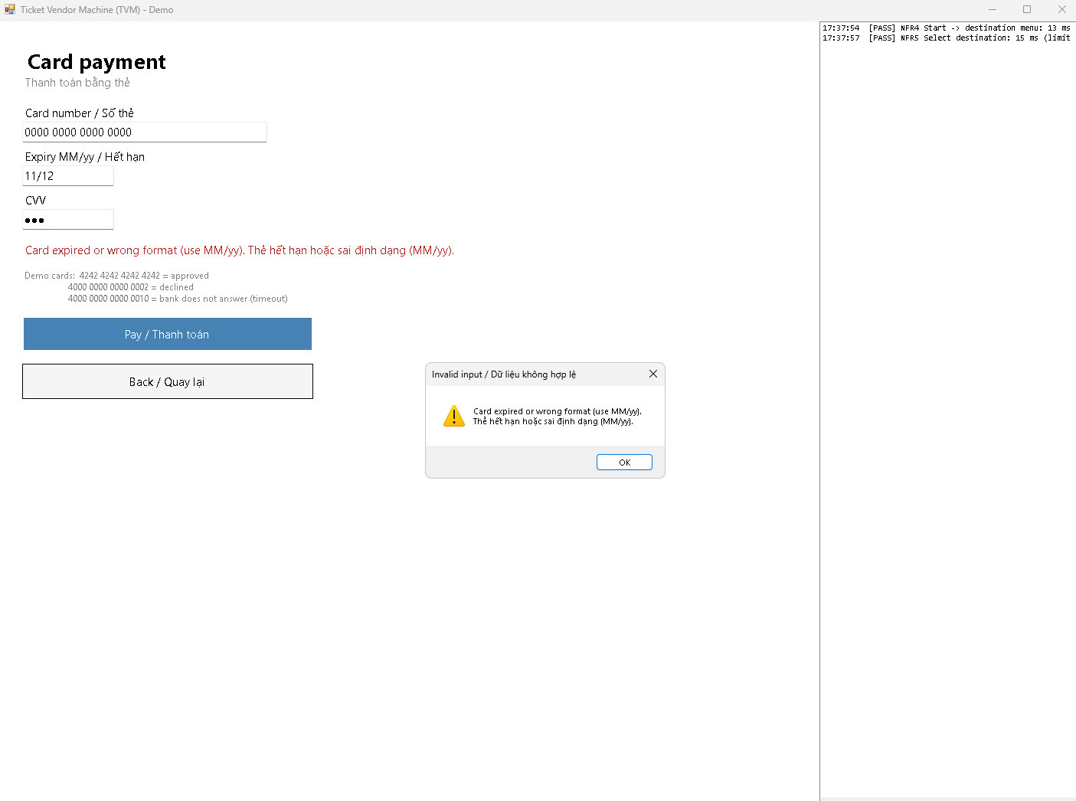
Test scenarios
No. | Scenario | Input | Expected result | Result
1 | [Successful purchase] | Any destination, card 4242 4242 4242 4242, expiry 12/30, CVV 123 | Success screen with ticket ID and barcode. | Pass
2 | [Payment declined] | Card 4000 0000 0000 0002, expiry 12/30, CVV 123 | Decline message, stay on the card form, no ticket issued, Payment status Failed | Pass
3 | [ ] | [ ] | [ ] | [ ]
Known limitations
[ ]

6. Checklist for "LabGroup_QT2_Assignment1.pdf"
No. | Item from LabGroupAssignment1.pdf | Where addressed in this report | Done
1 | Business context and problem statement (omitted and ambiguous requirements) | Section 1.2, Section 2.1 | Yes
2 | Clarification Q&A (Excel): ambiguities, questions and assumed answers | Section 2.1 | Yes
3 | Requirements specification: functional, non-functional and domain, with reliability and response time defined | Section 2.2 | Yes
4 | Use case diagram with detailed use case descriptions | Section 3.1 | Yes
5 | Activity diagram: passenger buying a ticket | Section 3.2 | Yes
6 | Activity diagram: integration with external payment gateways (Momo, VNPay, ZaloPay) | Section 3.2 | Yes
7 | “Buy a Ticket” detailed modeling: sequence diagram, state chart and class diagram | Section 3.3 | Yes
8 | UI/UX wireframes or mockups (Figma) | Section 4.1, Appendix A (Figma link) | Yes
9 | Architecture design diagram and deployment diagram | Sections 4.2 and 4.3 | Yes
10 | Visual Studio forward engineering (model to code) | Section 5.1.1 | Yes
11 | Visual Studio backward engineering (code to model) | Section 5.1.2 | Yes
12 | Code Map of the compiled code | Section 5.1.3 | Yes
13 | GitHub source control with a committed history showing collaboration | Section 5.2.1 | [Check numbers against GitHub Insights]
14 | AI assistance: prompts used, how the AI helped, how the output was validated | Sections 5.2.2 and 5.2.3 | Yes
15 | Demo application in C# and MSSQL, with an input form and output report or success screen | Section 5.3 | Yes
16 | Report file with diagrams, requirements, AI documentation and screenshots | Whole report | Yes
17 | readme.txt with the GitHub link, Figma link and database script instructions | Appendix A | Yes
18 | % contribution of each member | Section 7, Appendix A | Yes
19 | All final artifacts uploaded to the shared GitHub repository | Section 5.2.1, Appendix A | Yes

7. Contribution of Each Member
Member | Student ID | Work products and tasks | % contribution
Pham Minh Tai | 524K0025 | Phase 1 | 20%
Vu Hoang Phuc | 524K0024 | Phase 2 | 35%
Truong Minh Quang | 524K0038 | Phase 3 | 15%
Pham Le Duc Tri | 524K0040 | Phase 4 (Visual Studio Engineering; Github & AI Tooling) | 15%
Nguyen Ngoc Nhat Minh | 524K0022 | Phase 4 (Github & AI Tooling; demo) | 15%
Total |  |  | 100%

8. Conclusion and Lessons Learnt
What we achieved: Over four phases, we took the Ticket Vendor Machine from a problem statement to a working demo. First we worked out what the system should do and wrote the requirements. Then we modelled it with use cases, activity diagrams, a sequence diagram, a state chart and a class diagram. After that we designed the screens in Figma and drew the architecture and deployment diagrams. In the last phase we generated the C# classes from our class diagram, updated the diagram from the code, made a Code Map, and built a WinForms app connected to a SQL Server database.

In the demo, a passenger can press Start, pick a destination, see the fare, and pay by card or QR code. The machine then issues a ticket with a barcode, and everything is saved in the database. We also tried to cover the things that go wrong: a declined card, a bank that doesn’t answer, an expired QR code, a printer that runs out of paper (the payment is refunded), and a passenger who walks away (the session expires after 60 seconds). A report screen lists every transaction, and a log panel shows how long each step took compared with our response-time requirements.

Limitations: The payment part is a mock, so we did not connect to a real bank, so the QR code is only a picture and can’t be scanned. The “printer” is just a paper counter. The app has no login and runs on one computer, and the fares are sample numbers, not the real ones.

- Pham Minh Tai (Phase 1): Writing the requirements taught me that a requirement is only useful if you can test it. “Fast” means nothing, but “menu within 2 seconds for 950 out of 1,000 requests” does. I also saw how many hidden questions a short problem statement has, like what happens if the payment works but the printer fails.

- Vu Hoang Phuc (Phase 2): Drawing the use cases, activity diagrams, sequence diagram, state chart and class diagram showed me that they all have to agree with each other. If one changes, the others break, which is why our consistency check was useful. Writing the exception flows also made me think past the happy path.

- Truong Minh Quang (Phase 3): Designing 14 screens in English and Vietnamese, each linked to a use case step, showed me how many different states a simple machine really has. Failed, pending, expired and out of service all need their own screen. The deployment diagram taught me why the card reader talks to the bank directly and why only one callback endpoint is open to the internet.

- Pham Le Duc Tri (Phase 4, Visual Studio engineering): I learnt that generated code is only a skeleton. The get => default stubs silently ignored every value, and we only found out by asking why. I also learnt to keep the diagram and code matching by building after each change, and that Class Designer’s limits (no composition tool) mean choosing a sensible workaround.
- Nguyen Ngoc Nhat Minh (Phase 4, demo): Building the demo showed me why the earlier phases matter. Keeping our class names made the code easy to organise, but the empty methods had to be filled in and their signatures changed. I learnt to hide payment behind an interface so a fake bank can stand in, to check that a payment answer is genuine, and to ask for the real status before a retry so nobody is charged twice. I also learnt not to trust AI-generated code until I had run every scenario myself.

Appendix

Appendix A: readme.txt
Database link:
added database for demo testing · plDucTri/Ticket-Vendor-Machine@d82eebc

GitHub link:
https://github.com/plDucTri/Ticket-Vendor-Machine
Figma link: https://www.figma.com/design/zp3wZjqfM5GrwHQVnmTpJq/524k0022_524k0024_524k0025_524k0038_524k0040?node-id=0-1&p=f&t=qkGJpQBazZOwNH8z-0
Database script instructions
%contribution
Member Student ID Phase % contribution
Pham Minh Tai 524K0025 Phase 1 20%
Vu Hoang Phuc 524K0024 Phase 2 35%
Truong Minh Quang 524K0038 Phase 3 15%
Pham Le Duc Tri 524K0040 Phase 4 15%
Nguyen Ngoc Nhat Minh 524K0022 Phase 4 15%
Total 100%

Appendix B: Full-size Diagrams
Use case diagram

Activity diagram: buy a ticket
Activity diagram: payment gateway integration
Sequence diagram: Buy a Ticket
State chart diagram
Class diagram

Architecture Diagram
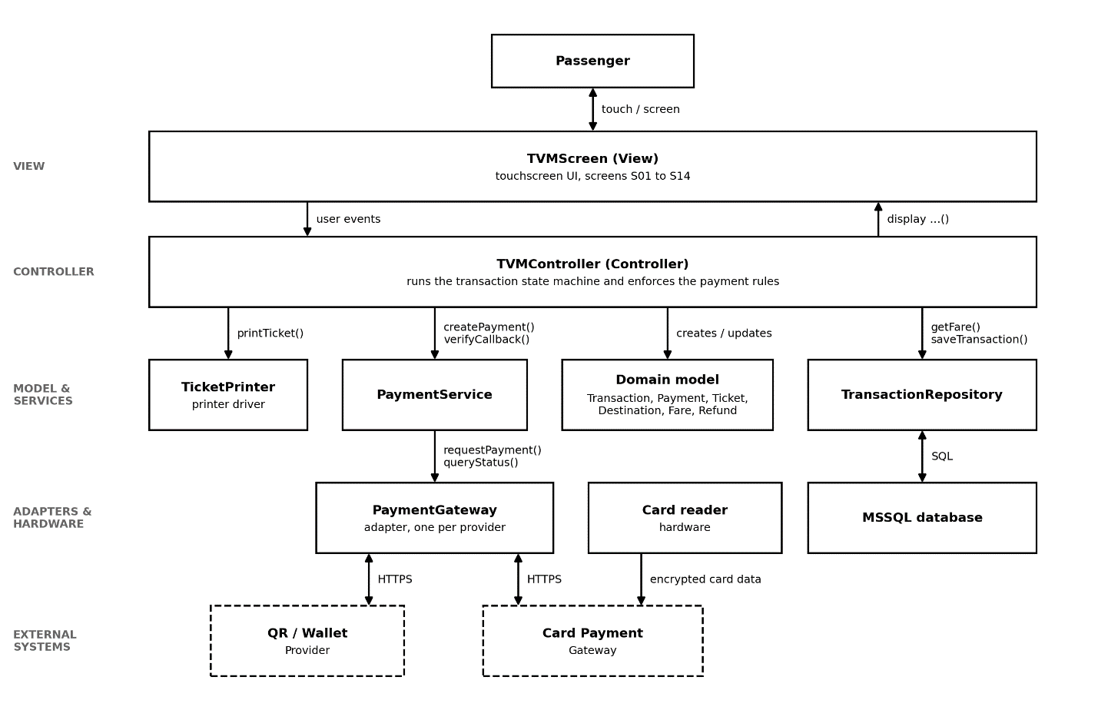

Deployment diagram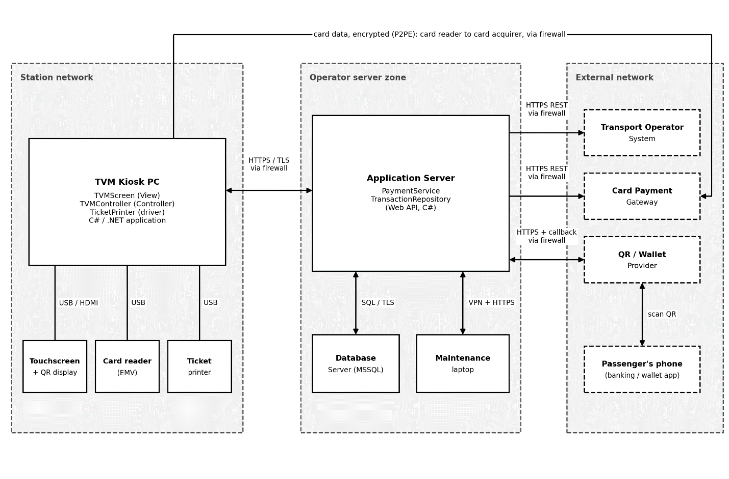
Class Diagram after forward engineering
Class diagram after backward engineering

Code Map

